**Zach Adair MSDS 610: Week 1 Lab Exercise**

**1/17/2019**

**Installing Oracle VM VirtualBox, Linux OS, and HADOOP**

**Regis University – College of Computer & Information Systems**

**Data Science – Data Engineering**

# **Part 1 – Install VM and OS**

## Install Virtualization Software

Follow the link below to download to install the virtual software – Oracle VirtualBox for my Windows operating system.

<http://www.oracle.com/technetwork/server-storage/virtualbox/downloads/index.html>

Clicking the link will send you to the page below

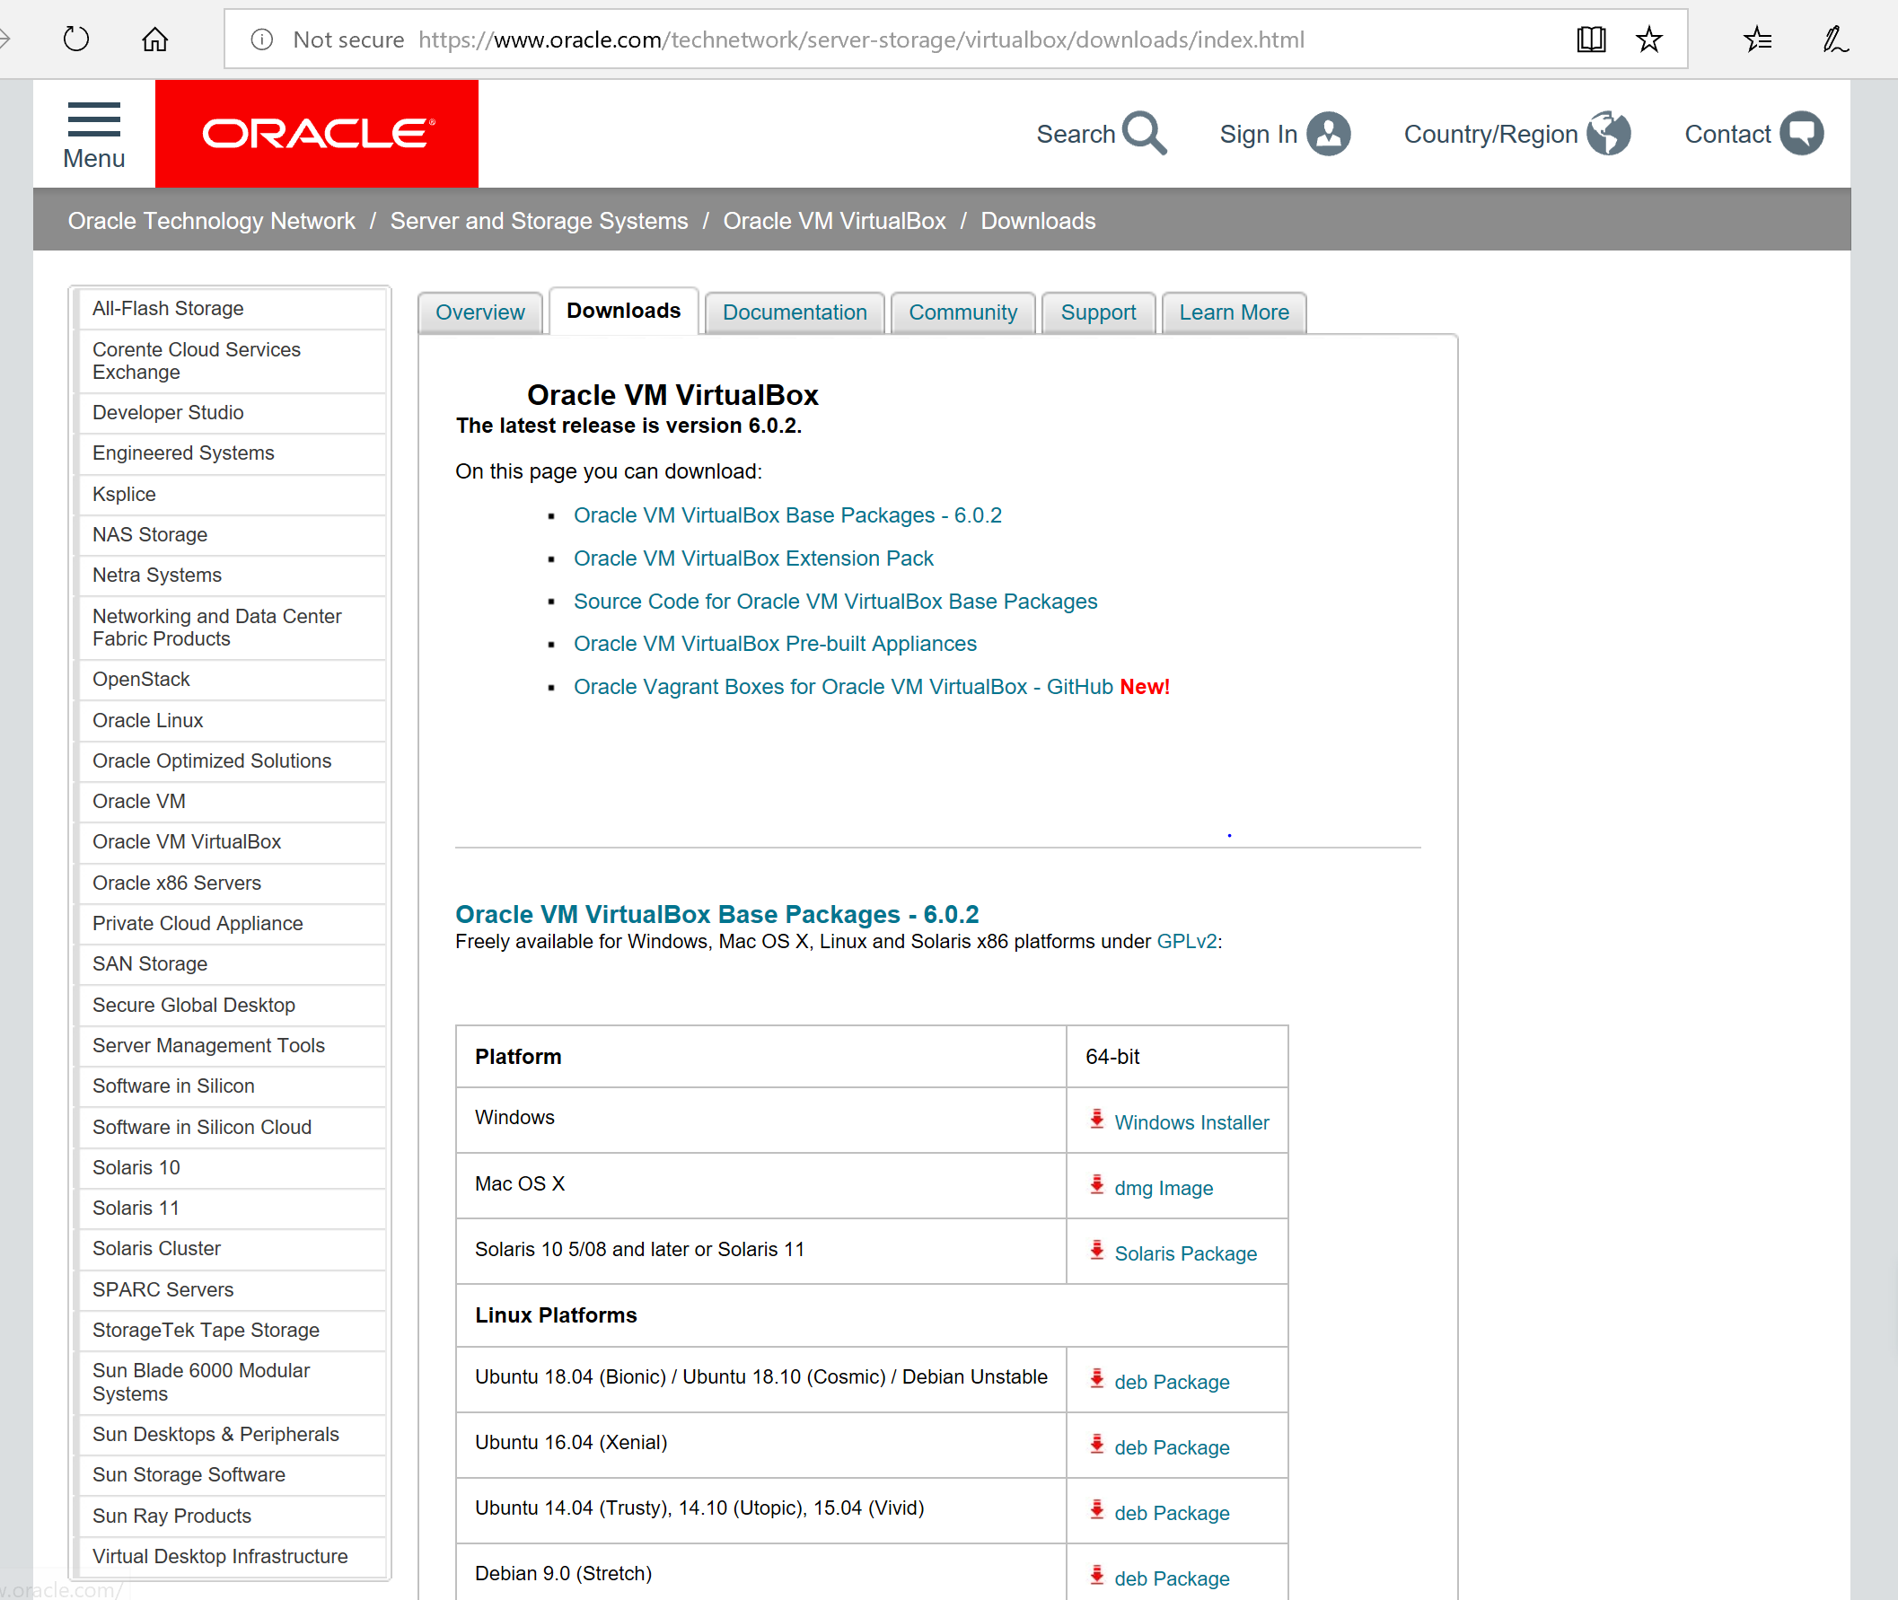

Download the file, and open the install file and install the application onto the system

## 1.2 Download ISO image of Linux operating system – CentOS 7

Download the ISO image from any mirror site. To find a mirror site for download use this url: <http://isoredirect.centos.org/centos/7/isos/x86_64/>

Below is the list from the page when I got to the mirror site



Below is the index I used and the file from here I selected is Cent0S-7-x86_64-Minimal-1810.iso

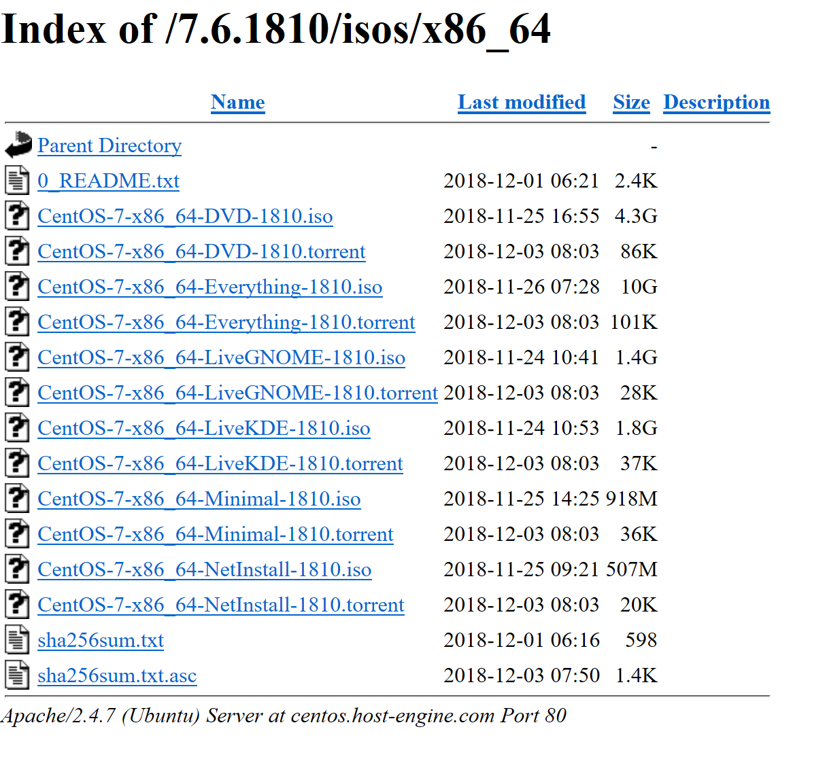

The size of the file is rather large so it will take a few minutes to download.

## 1.3 Configure a VM using Virtual Box

Start Oracle VM Virtual Box.

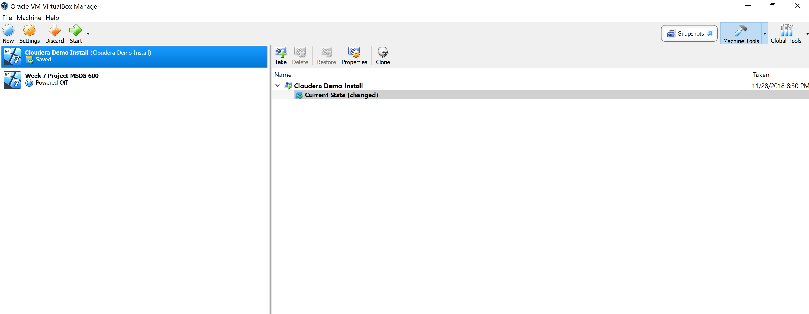

Start by clicking the New button at the top left of the window

Change the parameters to the settings that fit your computer

1. Name – MSDS 610 Lesson 1

2. Type – Linux

3. Version – Fedora (64-bit)

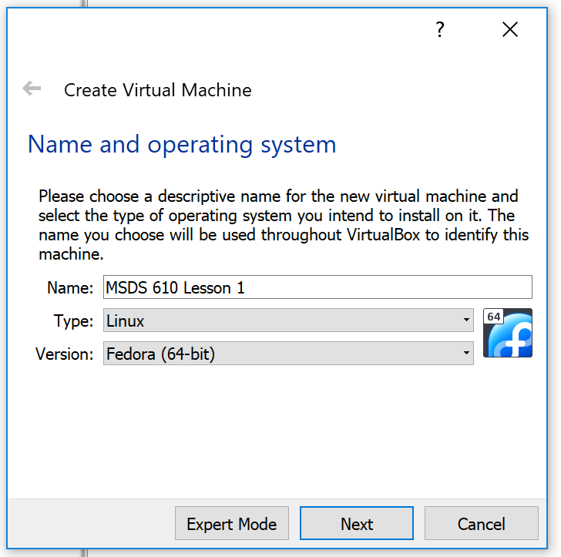

Increase the memory size to 8 MB (8192) Then, follow the screenshots below

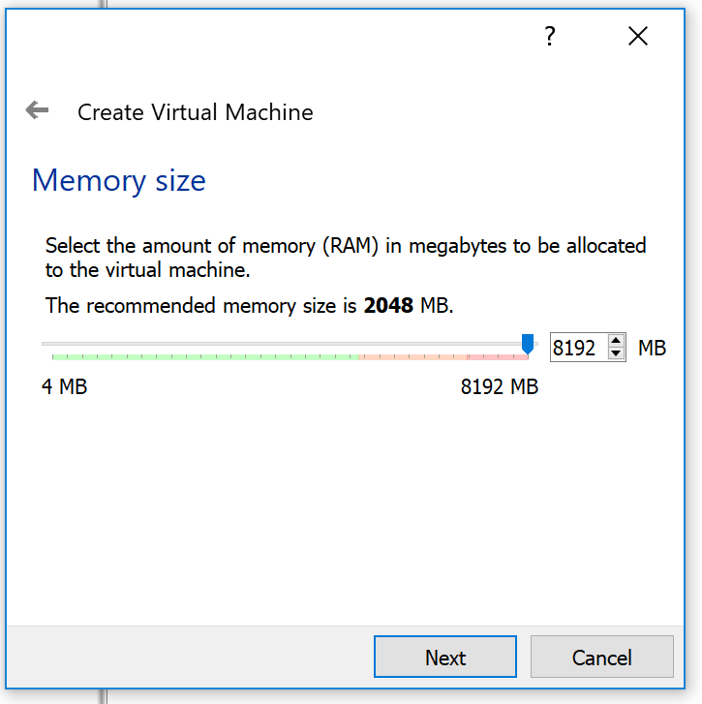

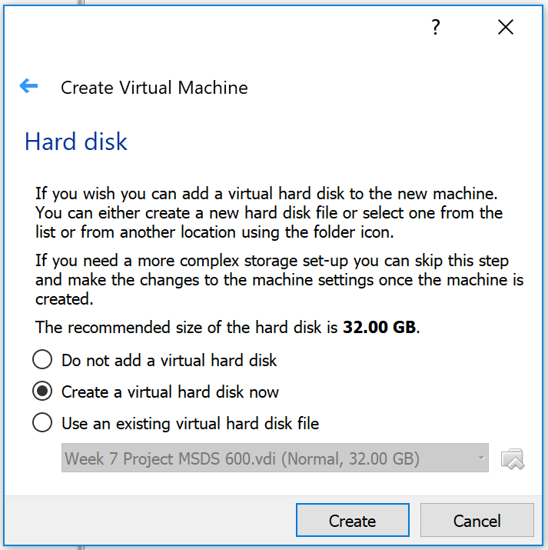

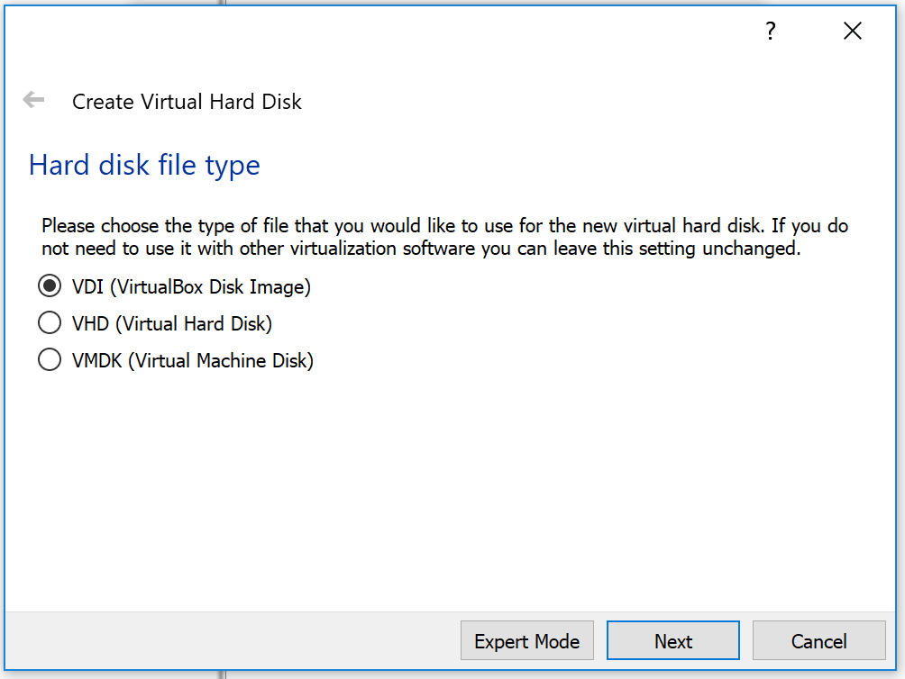

Change the hard disk option to Fixed Size, and click continue

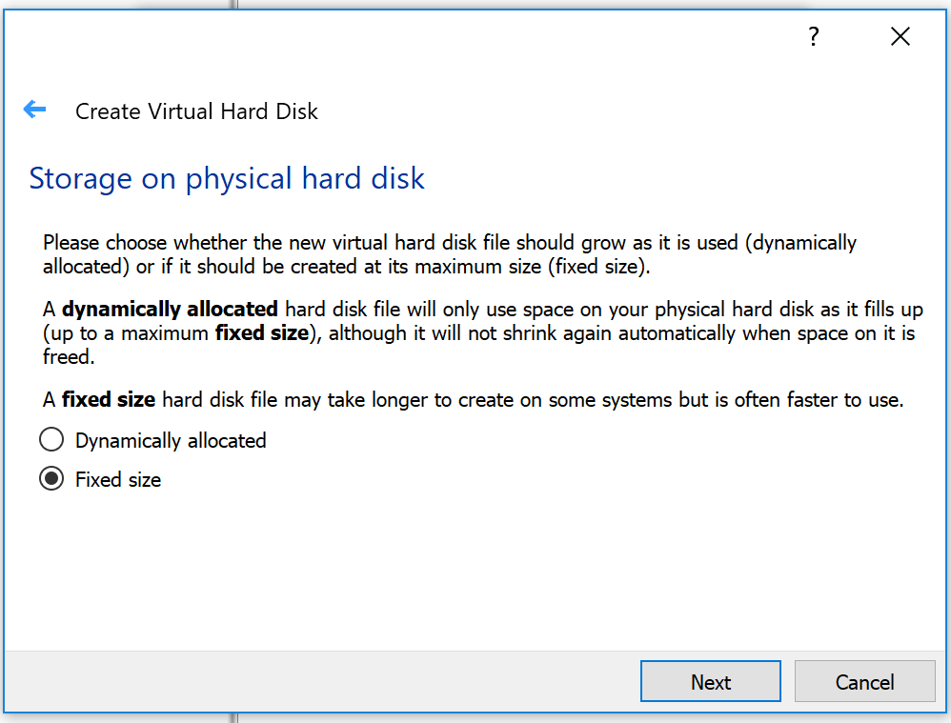

Set the size to 20G, and click create.

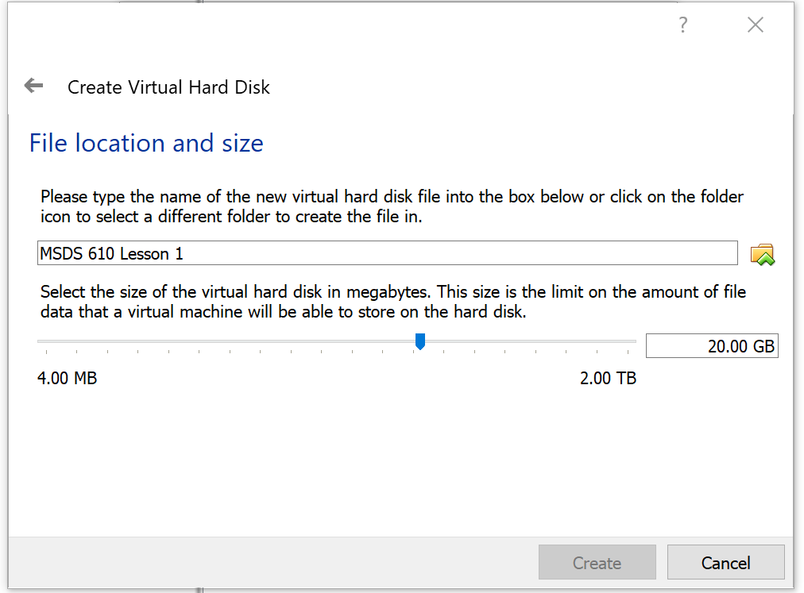

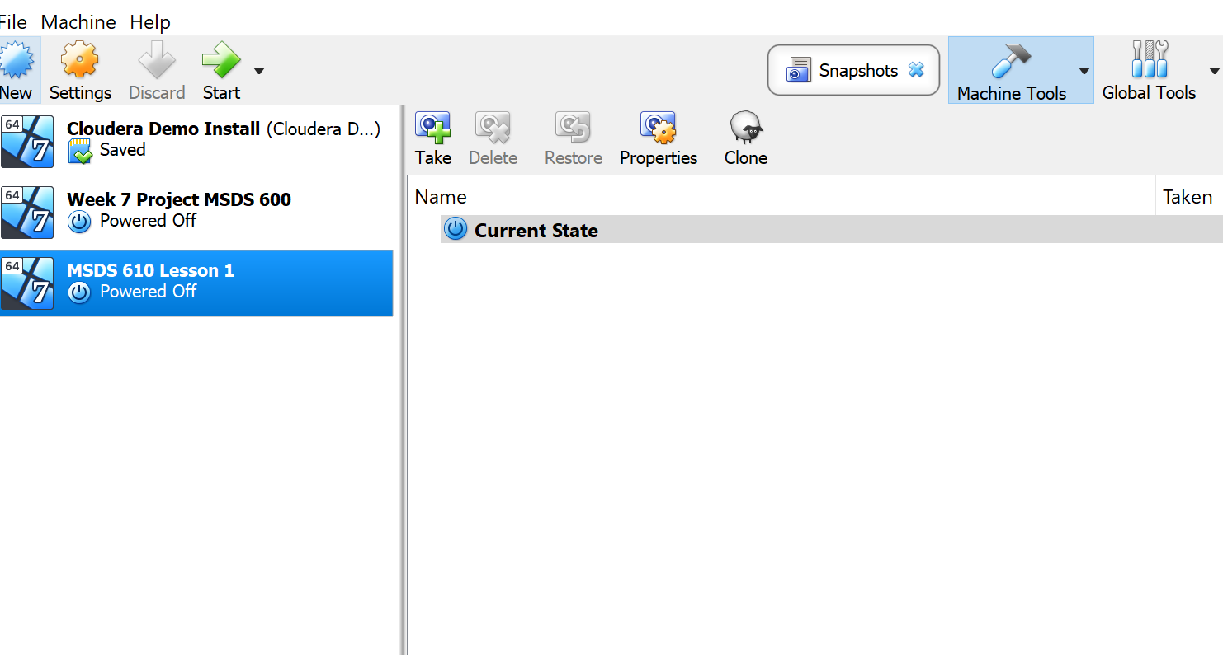

Back on the home screen and you can now see the new environment has been created.

Next go to settings

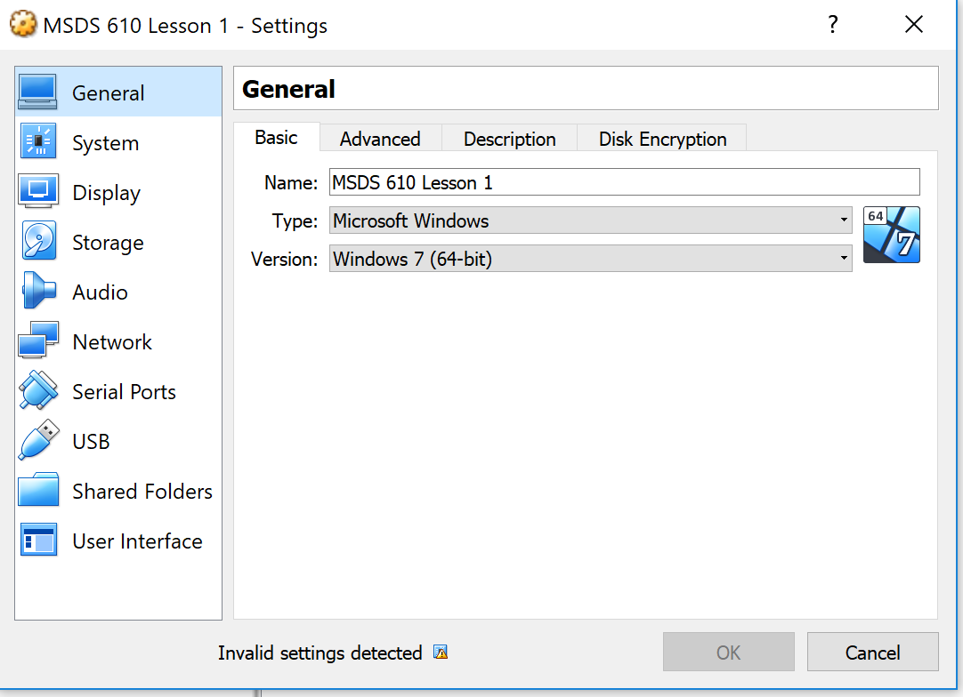

Select the Storage option

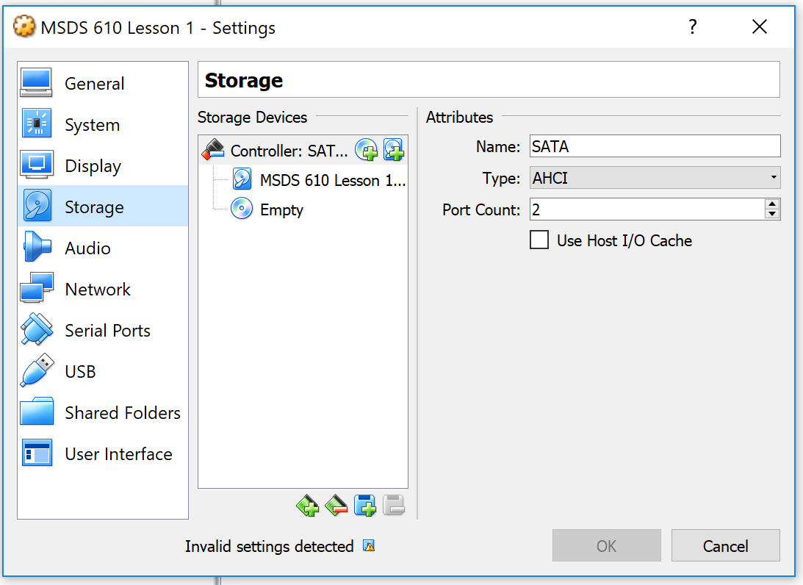

Click the disk labeled Empty, go to the far right part of the window and select **Choose Virtual Optical Disk File**. This will open the file browser

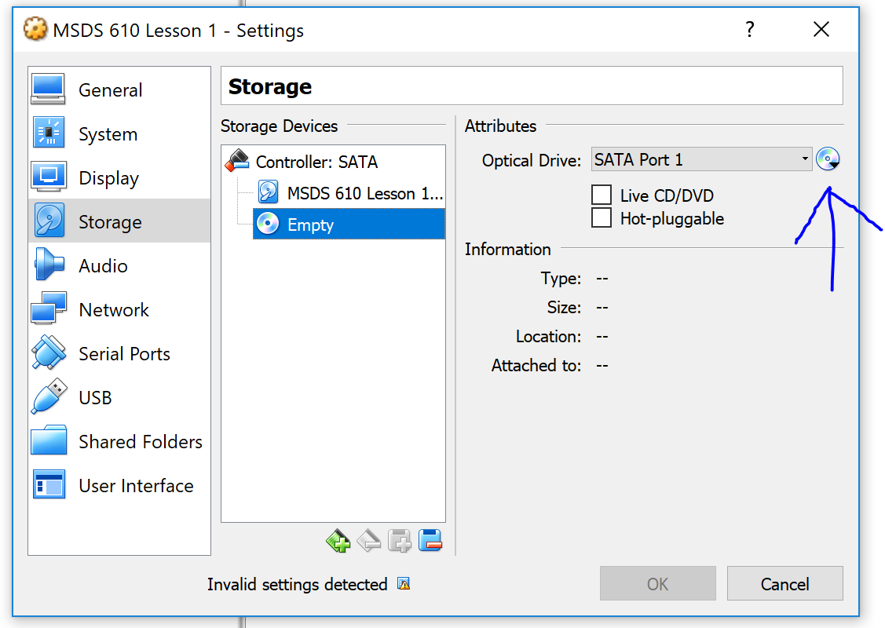

After grabbing the iso file downloaded, you will get the screen below

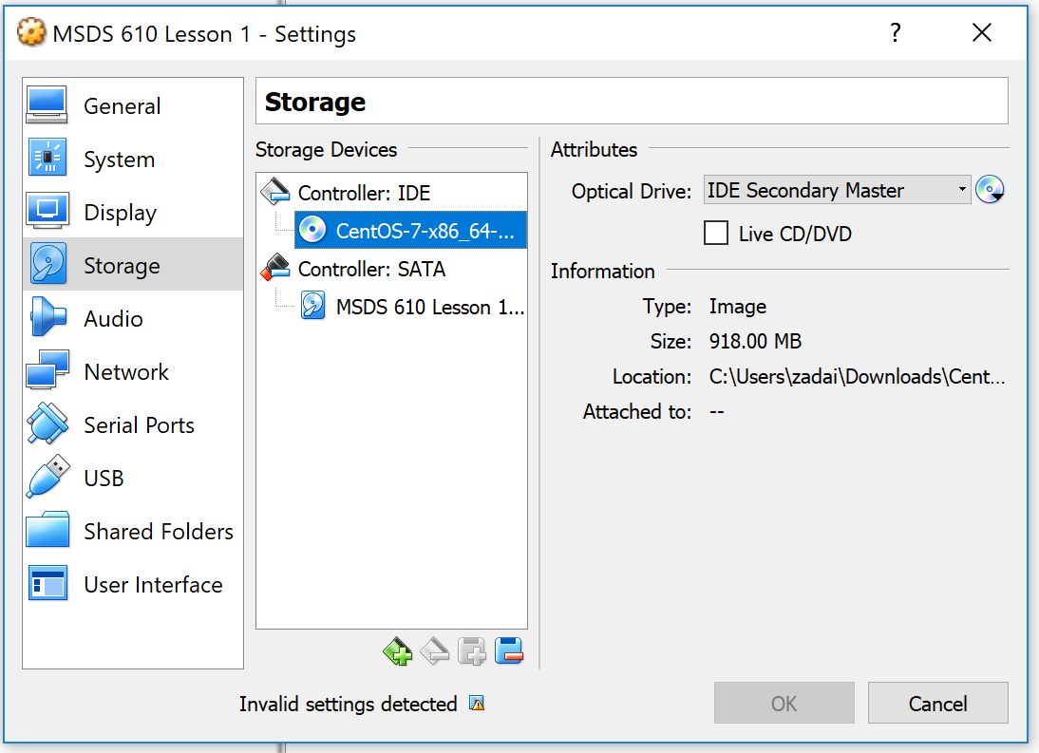

## 1.4 Install CentOS 7

Click the green Start Button to start the operating system installation process. Your virtual machine will Boot from the CD/DVD device w/ the ISO image of CentOS 7

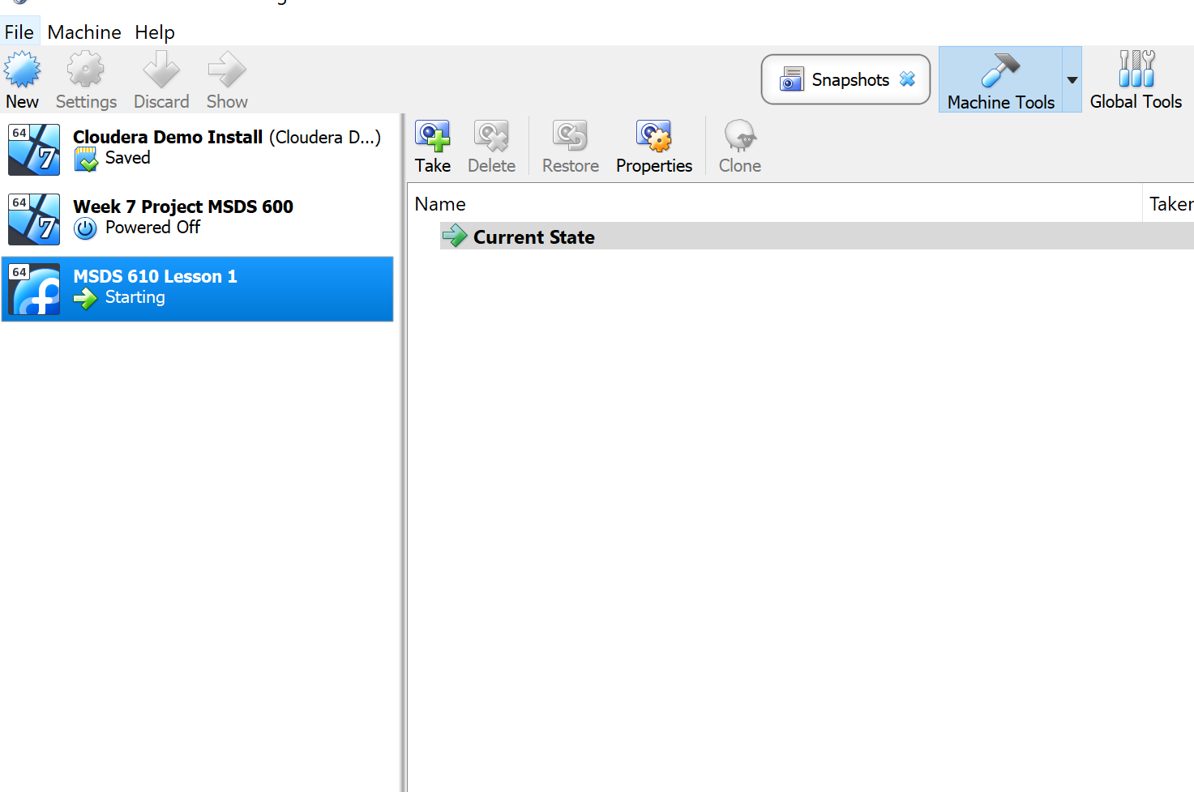

After going through the set up you will reach this screen below:

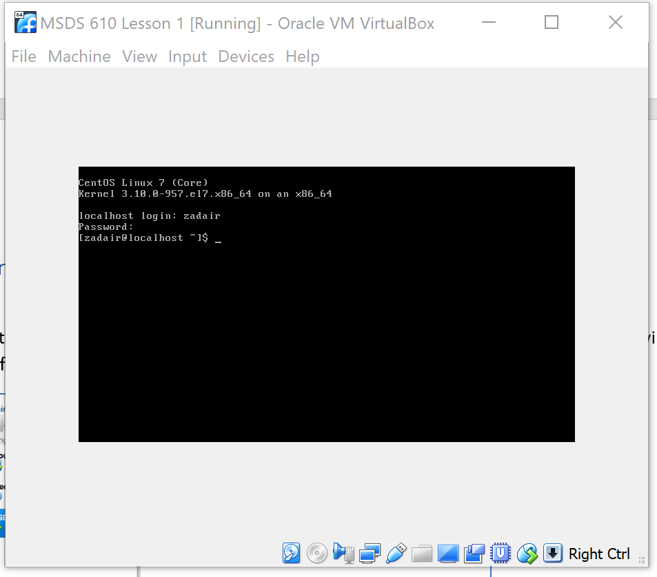

Getting the screen above and that final line means you correctly set up your Linux prompt

**Tech tip: Linux is case-sensitive; a command with a lower case Is is different from a command of upper case LS. This can be problematic with files names or variable names, so please keep that in mind as you navigate through this lab. CASE MATTERS**

## 1.5 Initial Steps with CentOS 7

You will now work on connecting to your server via SSH. Depending on the configuration of your PC, and what type of network you are installing from, there are a few options to get this piece configured. The following is the first option, then, if it doesn’t allow you to connect successfully please try option 2 or 3.

### Option 1:

If you enter the ‘ip addr’ at the command prompt, your response will be similar to the following:

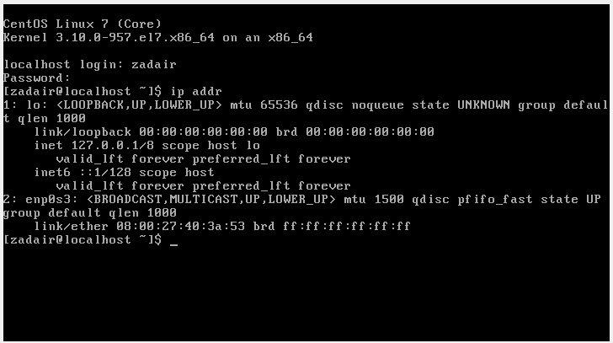

Here you see two network adapters. The first is the loopback adapter that allows the operating system to talk to itself via TCP/IP. The second adapter is the ethernet adapter. In my case, the IP address for this adapter is 127.0.0.1/8 scope host lo

During the installation of the VirtualBox software virtual networks were installed. These networks are private subnets that are similar to what is provided with the router in your home. The VirtualBox software includes a software router that has a DHCP server. It provides network addresses and configuration to your virtual machines

Your interactions with the CentOS 7 virtual machine will be through a Command Prompt or Terminal prompt type of interface. There is no GUI. An ssh client will provide an easy-to-use means to access your virtual machine. It is recommended that you use an ssh client and not interact with the virtual machine through the window in the VirtualBox software. More details will provided soon about the SSH shell

## 1.6 Navigating CentOS 7

Linux is a multiuser operating system. Files and directories in Linux are stored in an hierarchical file system. When you login to Linux you are in the home directory associated with your user name. If you type the pwd command you should see that you are in your users home directory

The command pwd (present working directory) will return the name of the current directory

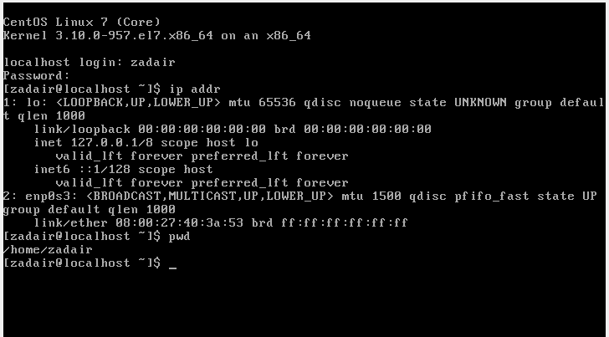

**Other commands**

* ls – lists the contents of the current directory. The ls command can take a variety of arguments. So for instance, ls -la will provide a more detailed listing of the contents of a directory that include hidden files, files whose first character is a dot.
* cd – changes the current directory to another directory. The cd command takes an argument which is the name of the destination directory. The cd command allows you to navigate the directory hierarchy
* cp - copies a file. It takes as arguments the name of the file to copy and the name of the destination file.
* mv - moves a file. It takes as arguments the name of the file to move and the destination of the file.
* rm - deletes a file. It takes as an argument the name of the file that you wish to delete.
* mkdir - makes a directory. It takes as an argument the name of the directory to be created.
* rmdir - deletes a directory. It takes as an argument the name of the directory to be deleted.
* cat - lists the contents of a file to the screen.
* more - lists the contents of a file to the screen a page at a time.

Find an online reference describing basic Linux or bash commands until you feel comfortable navigating and interacting with the Linux file system. Most commands contain help information that can be viewed by typing the command followed by –help.

Example,

ls --help

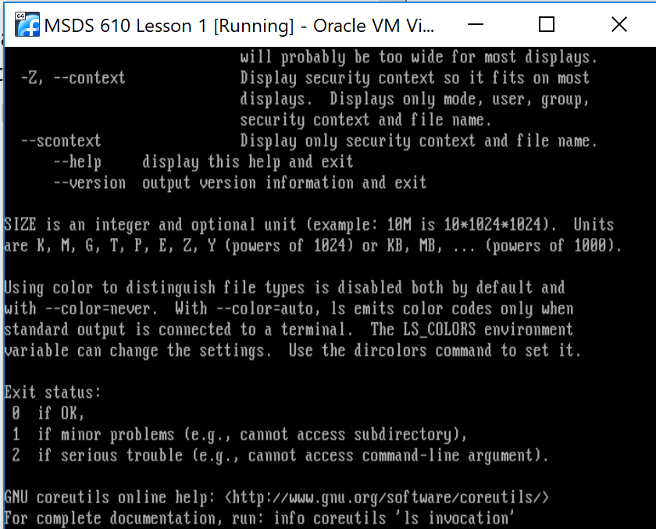

There also are manual pages for the commands and can be viewed using the man command.

Example, using the command: man ls

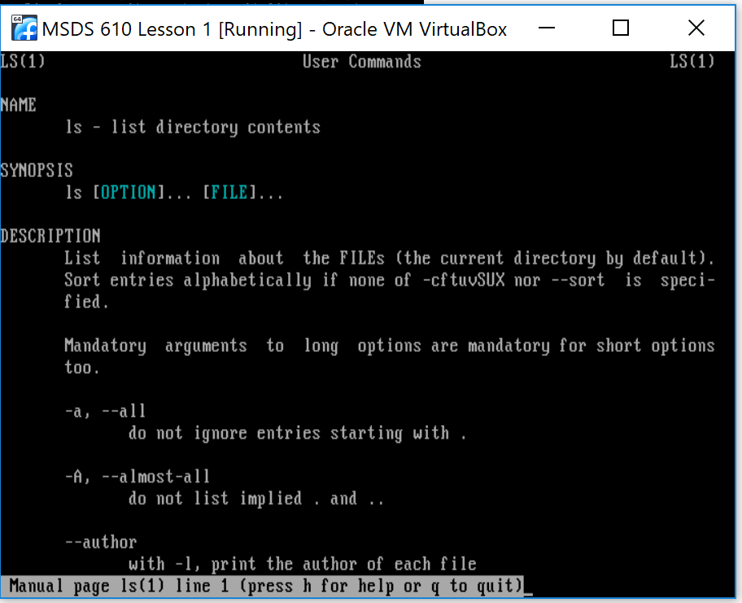

## 1.7 Initial System Administration Tasks

During installation of the operating system you configured a user name, with a password, and specified a password for root. Root is the superuser name. It is the user that has complete administrative access to machine. We will use it for general system administration tasks. To switch to the root user, use the su command

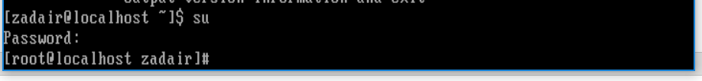

Notice that the username is now root

Note that this is not a username, but rather the name of the folder I’m currently located in, remember the pwd command above?

To exit Root, type the exit command. This will just log out of root, and you will now be logged in as the user you originally where before switching to root

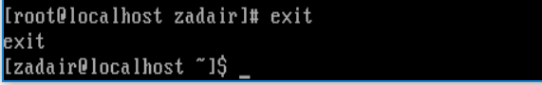

As the root user, you have ultimate control of the Linux environment. In general you should be extremely careful if you receive access to root. For this lab, just be careful since you are in a VM and if you mess things up badly, you might have to start from scratch to reinstall.

## 1.8 Update your operating system

To perform general updates to your operating system we will be doing the following steps

1) Become the root user

2) Execute the command yum update

The Yellowdog Updater, Modified (YUM) is an open-source command-line package-management utility for computers running the Linux operating system using the RPM Package Manager. Though YUM has a command-line interface, several other tools provide graphical user interfaces to YUM functionality.

Many messages will be displayed as the yum update runs.

Before running the yum update command, su back to the root user if you aren’t currently root

During installation of the updates you will need to reply yes to a few prompts to complete the actions.

This installation can take +10 minutes to complete

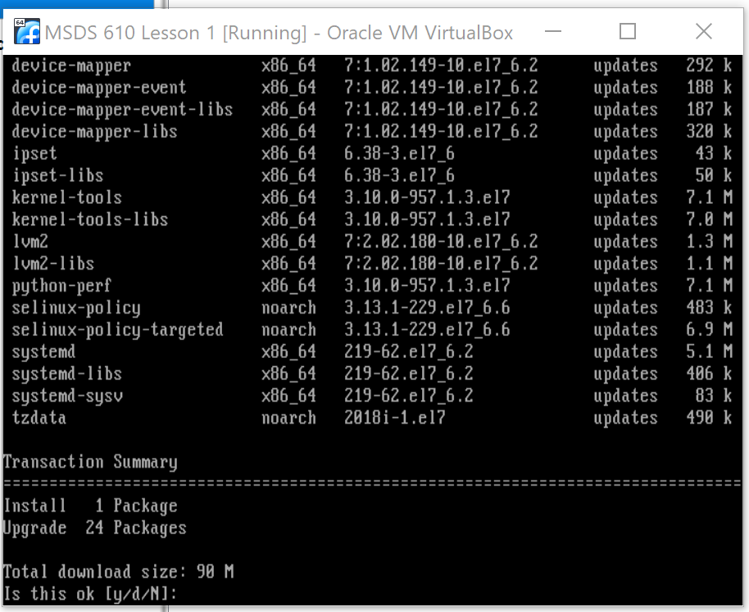

After the upgrade is complete it will notify you like below:

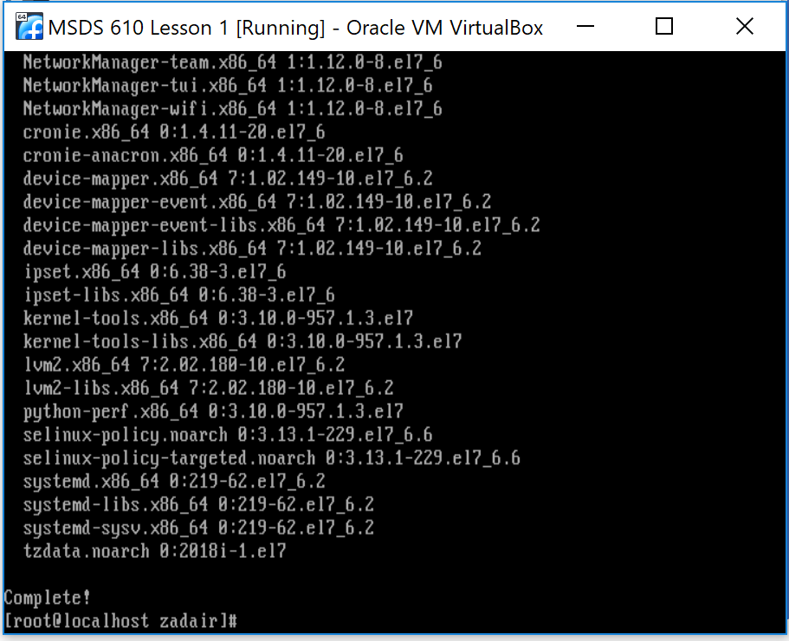

# Part 2 – Install and Configure Hadoop

## 2.1 Install Java

To install Java, as the root user enter the command yum install java-1.8.0-openjdk-devel

Tech Tip: If you are using Putty or Terminal to connect to the VM, then you can copy text and then right click the mouse to past into the putty command line.

This can save you some typing or typos

First part of the output from this command is: [root@localhost zadair]# yum install java-1.8.0-openjdk-devel

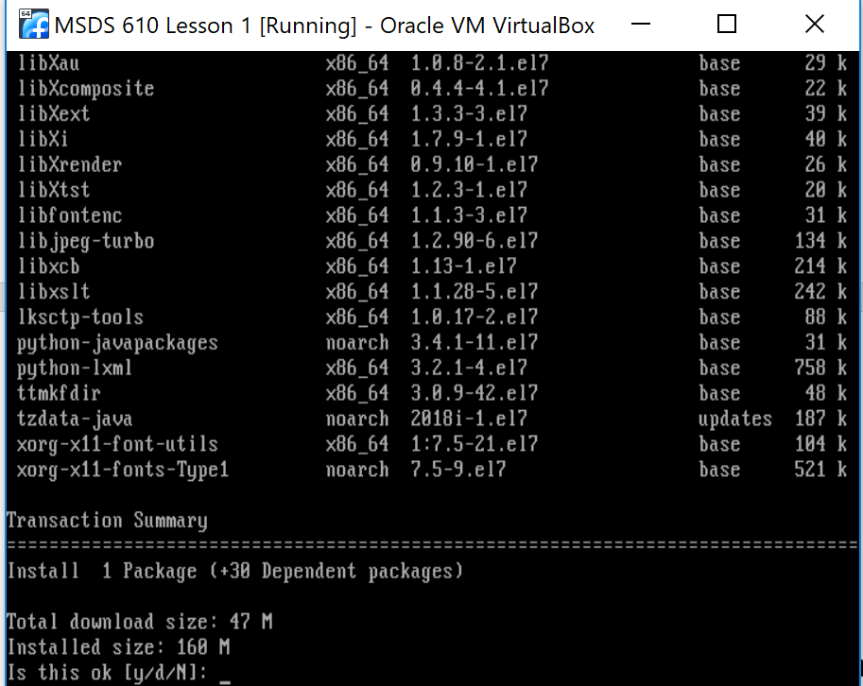

Like from earlier it will let you know when it is complete:

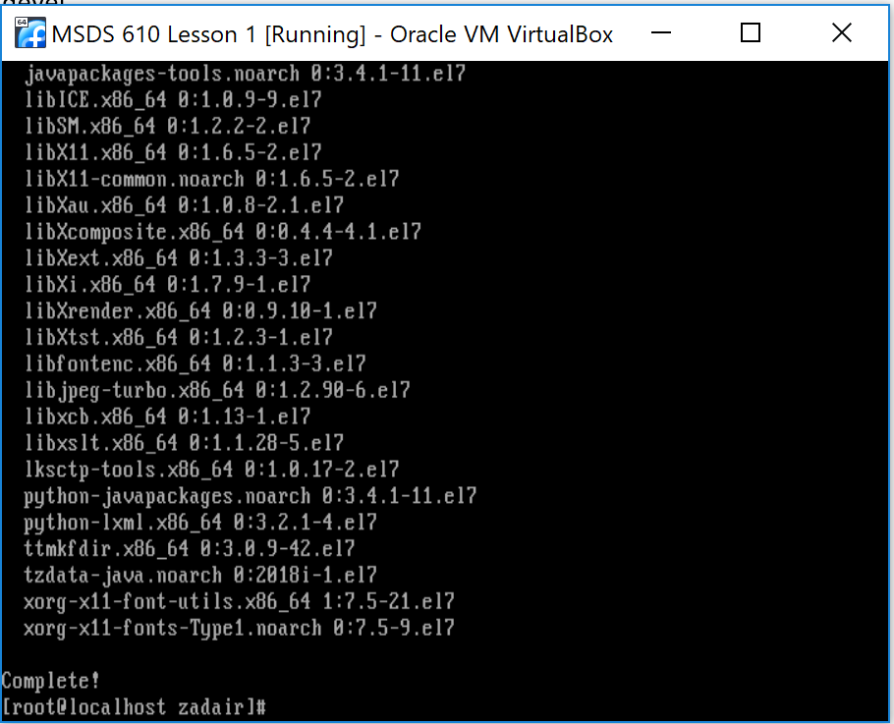

## 2.2 Install wget

The wget command is used to download files from the Internet. Install it using the yum command. You will use wget to download the Hadoop software from the open source website soon

[root@localhost zadair]# yum install wget

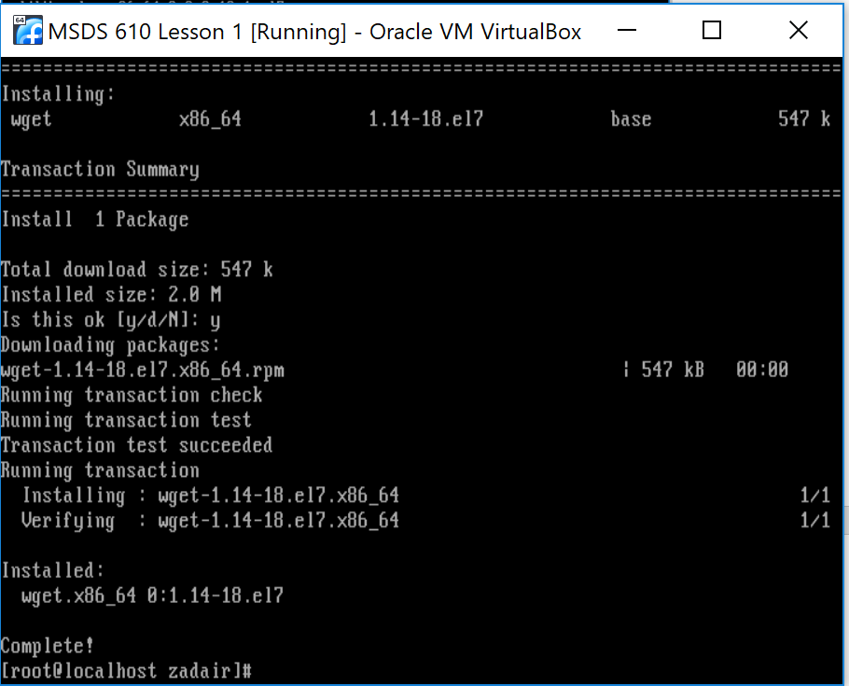

## 2.3 Create the Hadoop User

The useradd and passwd commands are used to create users in the Linux environment and then specify their passwords on your VM. Use these commands to create the Hadoop user.

[root@localhost zadair]# useradd hadoop

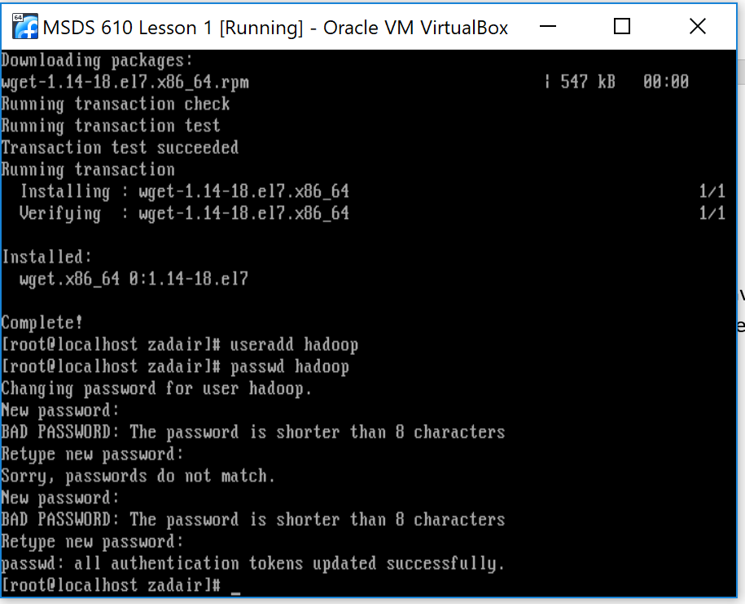

I used the simplistic password of hadoop even though I got the warning that it was a bad password for being shorter than 8 characters.

## 2.4 Configure Password-less Login for the Hadoop User

This may sound strange, but the Hadoop user needs to be able to login to the machine without using a password. Now is the time to pay close attention to the lab instructions, if you were not already. The commands go as follows:

Change directories to the new Hadoop directory. Verify your location with the pwd command

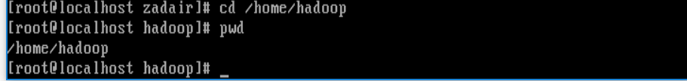

Create a new directory called .ssh within the Hadoop directory.

Then, change directories into the new directory .ssh

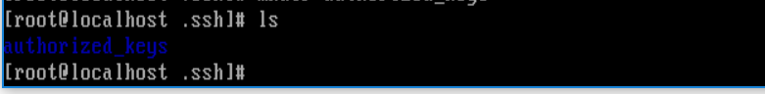

Change to the /home/Hadoop – home directory with the cd command as shown below

Verify location using pwd



Run the ssh-keygen command as shown below:

Ssh-keygen -t rsa

Tech tip: What is ssh-keygen?

Ssh-keygen is a tool for creating new authentication key pairs for SSH. Such key pairs are used for automating logins, single sign-on, and for authenticating hosts

You will be prompted for a new key file name and location. Use /home/Hadoop/.ssh/id_rsa

Press enter twice to leave the passphrase empty as shown below

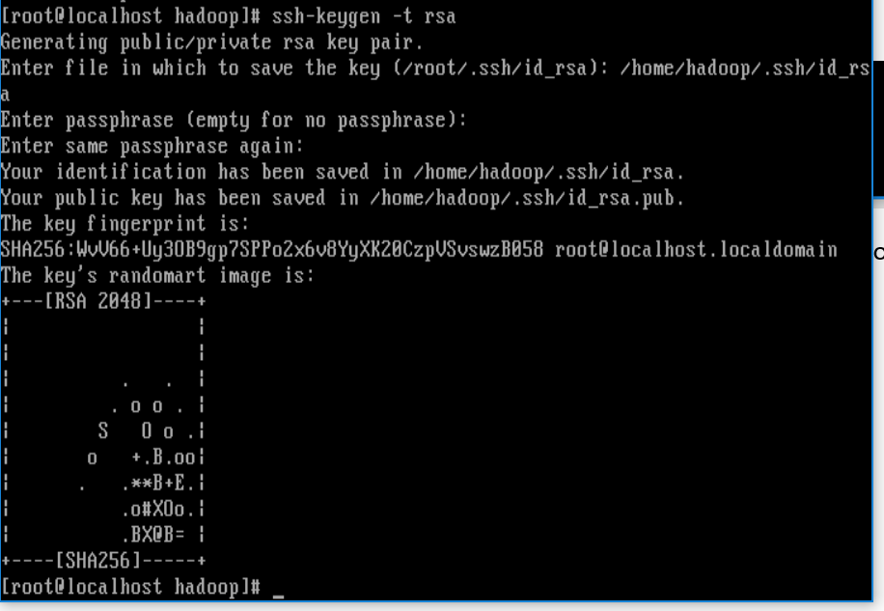

Verify the new files using the command: ls -l .ssh

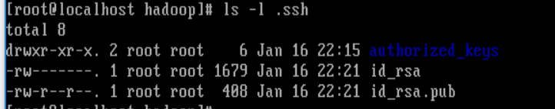

Use the ls command to verify the file in the authorized_keys directory as shown below:

cp .ssh/id_rsa.pub .ssh/authorized_keys

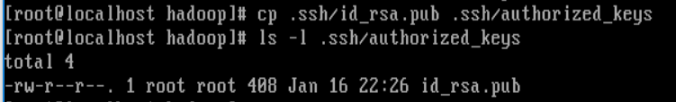

Using the root ID, change the owner and group of the .ssh directory and files using the chown Linux command as shown below. This allows the Hadoop_user to own the directories and files. Do an ls -l on the .ssh directory to verify the new owner.

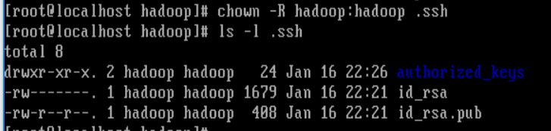

Exit from root and then exit again from the SSH session

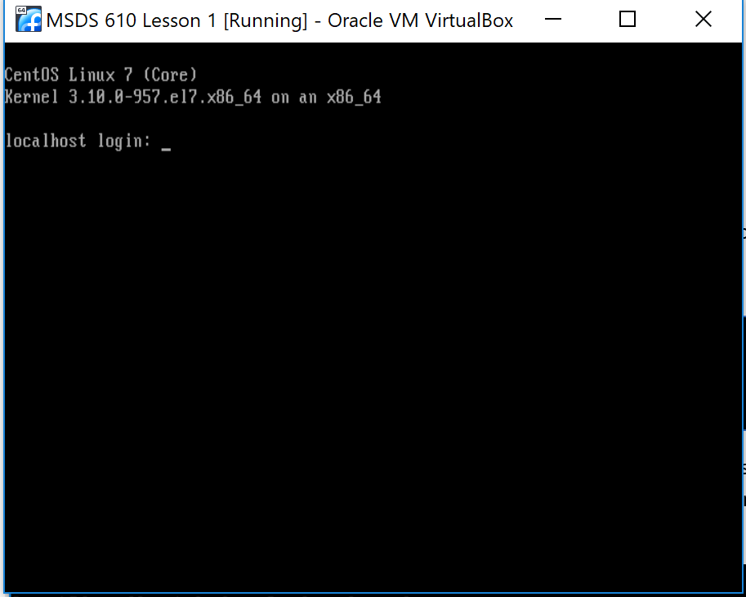

c  
Exiting twice will take you right back to the login prompt that is seen at the beginning of opening the environment

You are able to log back under the Hadoop user name and password

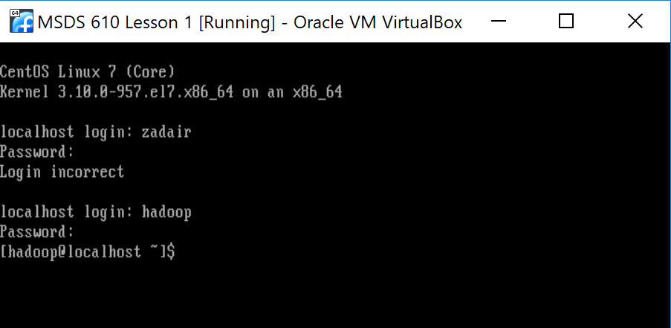

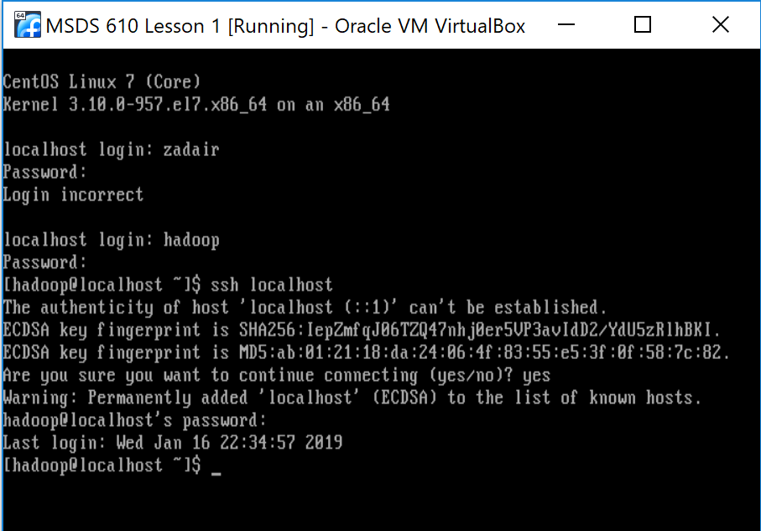

Verify the known hosts file using ls -l. Notice that a new file exists called known_hosts

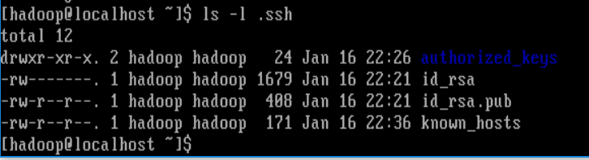

## 2.5 Download Hadoop

Open a browser window and then go to the Apache Hadoop website, <http://hadoop.apache.org>. You will use the wget command to download the 2.7.5 binary “tarball” to your virtual machine. Follow the steps below to find out the location and name of the “tarball”.

A window like below should open up:



After clicking “Getting Started” it will take you to a page like the one below, click on the link https://www-us.apache.org/dist/hadoop/common/

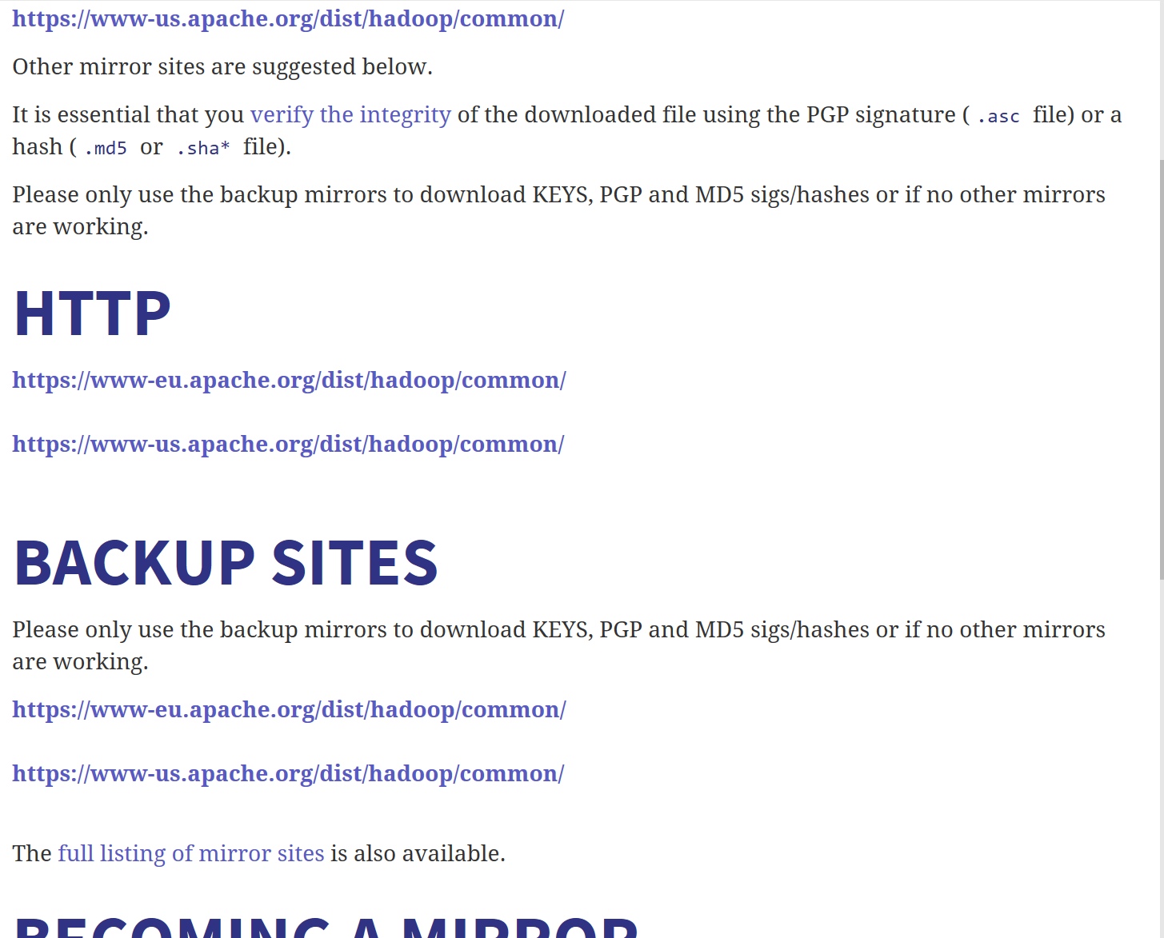

It will take you to the index of /dist/Hadoop/common like seen below. Now select current2/

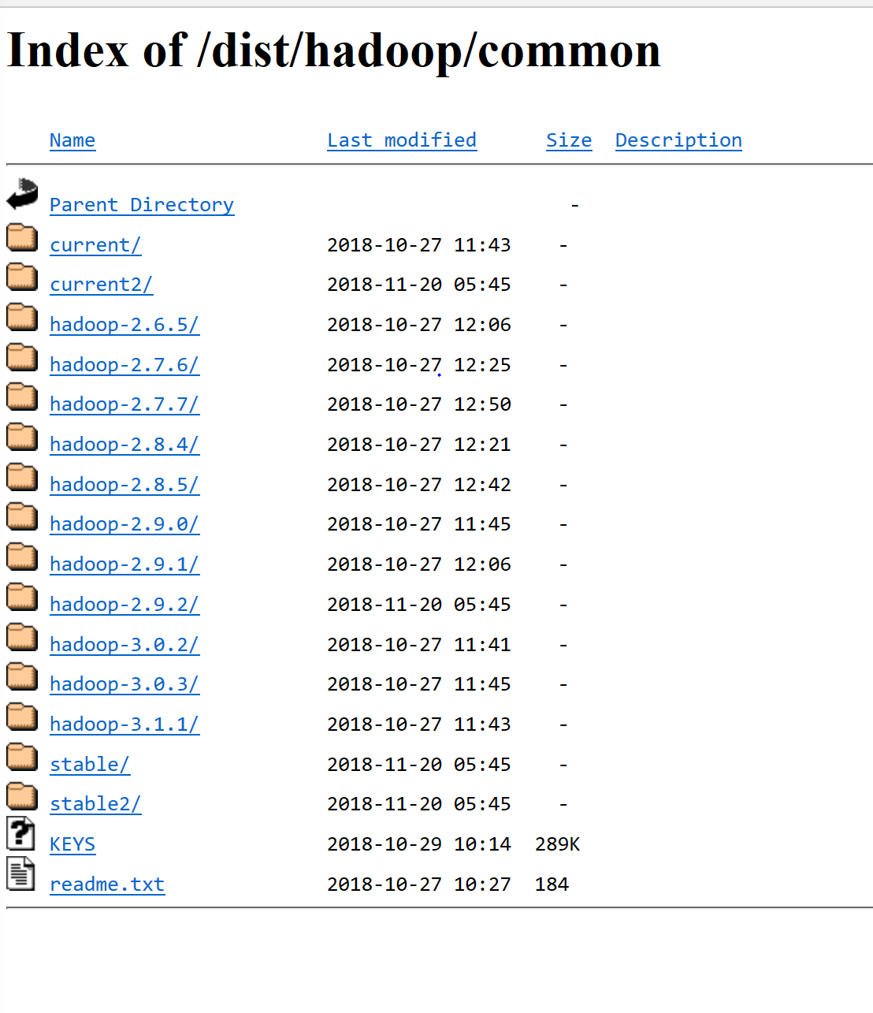

Right click 2nd option on the list in the index and choose the “Copy Link” option.

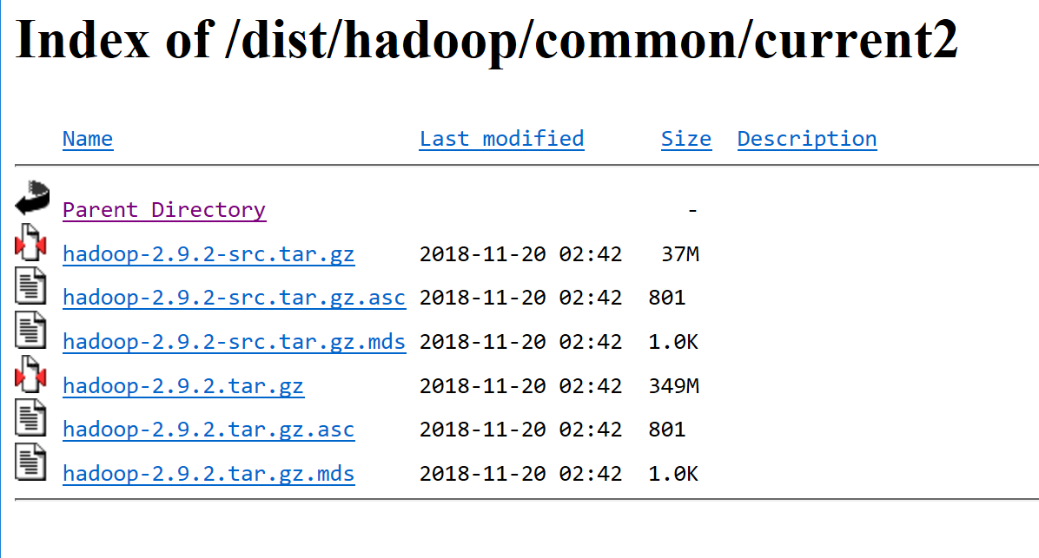

Now go back to the SSH session, and we will be using the wget command to download the binary “tarball” to your virtual machine since you know the location and file name.

Change the directory to the Hadoop users home directory

[hadoop@localhost .ssh]$ cd /home/Hadoop

[hadoop@localhost ~]$ wget http://apache.cs.utah.edu/hadoop/common/current2/hadoop-2.9.2.tar.gz

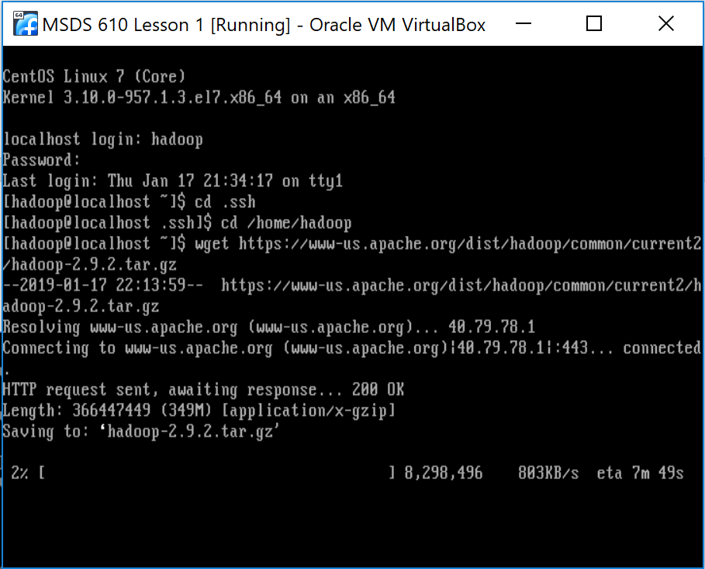

Unzip and untar the downloaded file using the tar Linux command. The -zxf are parameters that tell the tar program what it should do specifically with the file.

[hadoop@localhost~]$ tar -zxf Hadoop-2.9.2.tar.gz

After type the command ls command to check and make sure the new file is listed



Now unzip and untar the downloaded file using the tar Linux command. The -zxf are parameters that tell the tar program what it should do specifically with the file.

[hadoop@localhost~]$ tar -zxf Hadoop-2.9.2.tar.gz



Now try the ls -l command followed by the pwd

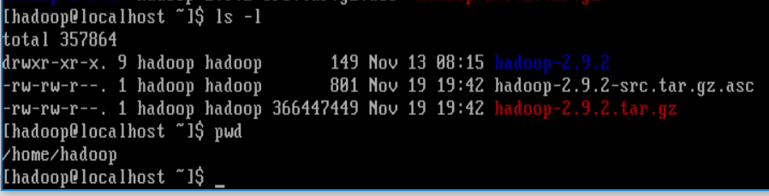

## 2.6 Install nano

To install nano, become the root user (remember the su command!) and then execute the command yum install nano. You will need to answer y to the prompt during the install.



Once completed you will see this code:

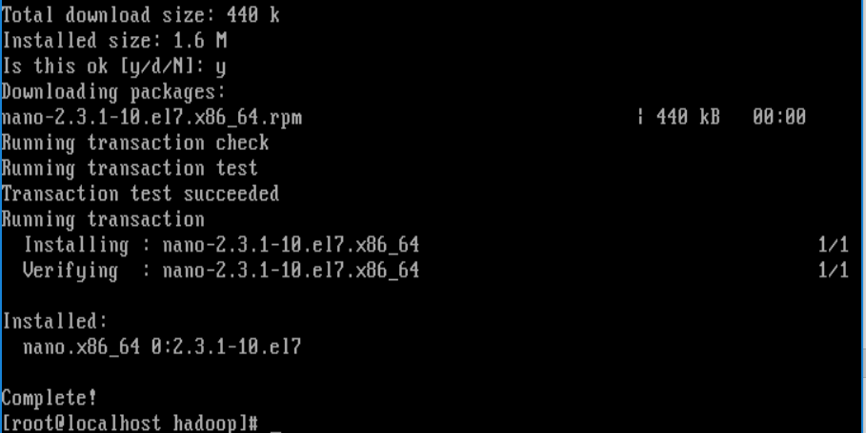

Once complete, exit out of root to the Hadoop user. Verify w/ pwd that you are in the Hadoop directory before proceeding and notice your prompt says Hadoop and not root

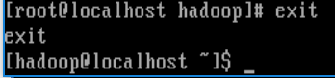

## 2.7 Configure Java

If you are not in the home directory for the Hadoop user (/home/Hadoop), return to it using the cd command. We will now edit the .bashrc file for the Hadoop user. This is the startup file that is executed automatically when you login with the Hadoop user ID

Use the command nano .bashrc

Result of the code:

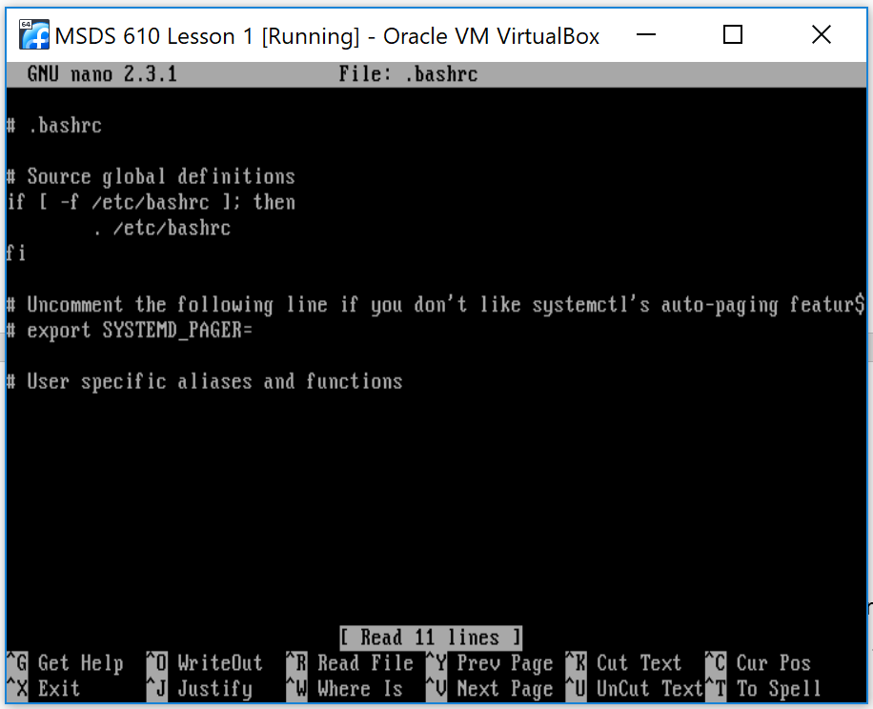

Add the following line at the end of the file. Copy the text and then write click to paste into the file

This export provides the location of the java software that you installed earlier and is needed for Hadoop and related software to run successfully.

Command: export JAVA_HOME=/usr/lib/jvm/java

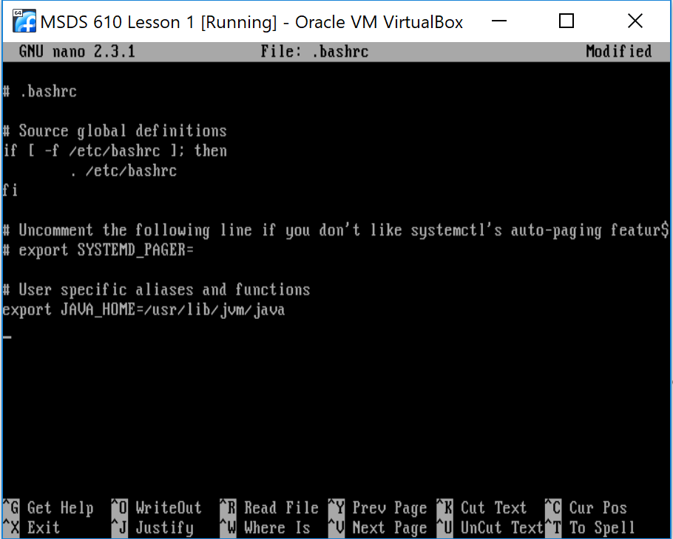

Then add the following lines after the line for java to the bottom of the file to configuring the Hadoop environment variables. These variables tell Hadoop where to find the files that it needs to start up and operate.

**NOTE: THE HADOOP HOME VARIABLE BELOW IS CALLED Hadoop-2.9.2…NOTE THAT YOURS MIGHT BE DIFFERENT IS YOU HAVE A SLIGHTLY DIFFERENT VERSION OF HADOOP.**

export HADOOP_HOME=/home/hadoop/hadoop-2.9.2

export HADOOP_INSTALL=$HADOOP_HOME

export HADOOP_MAPRED_HOME=$HADOOP_HOME

export HADOOP_COMMON_HOME=$HADOOP_HOME

export HADOOP_HDFS_HOME=$HADOOP_HOME

export YARN_HOME=$HADOOP_HOME

export PATH=$PATH:$HADOOP_HOME/sbin:$HADOOP_HOME/bin

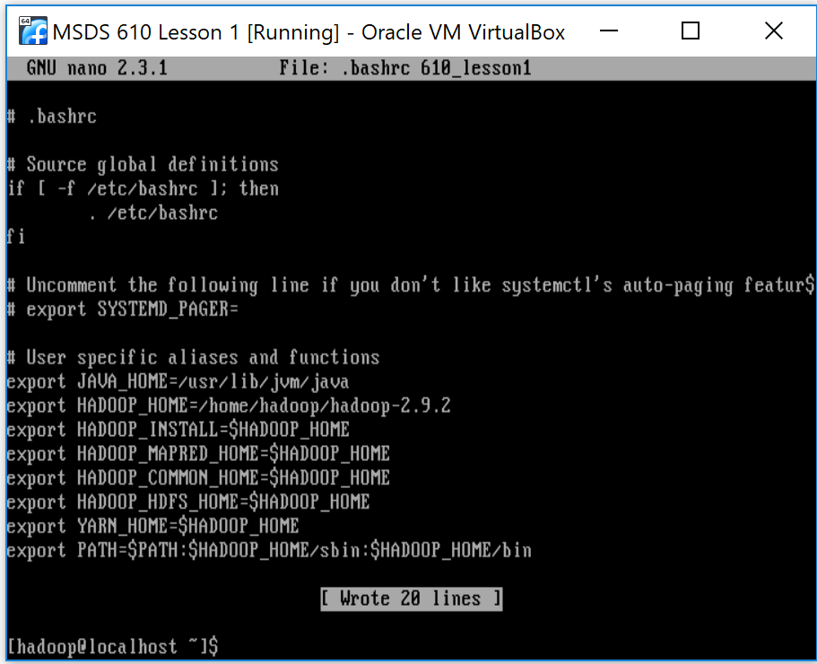

To save the file in Nano, press the control key (Ctrl) and the letter o. You will be prompted with the file name, press enter. To exit the file, press the control key (Ctrl) and the letter x.

You can verify that the added lines are in the file by typing Linux command – more .bashrc, which will print the contents of the file to the screen.

Use the command more .bashrc to see the contents of your file:

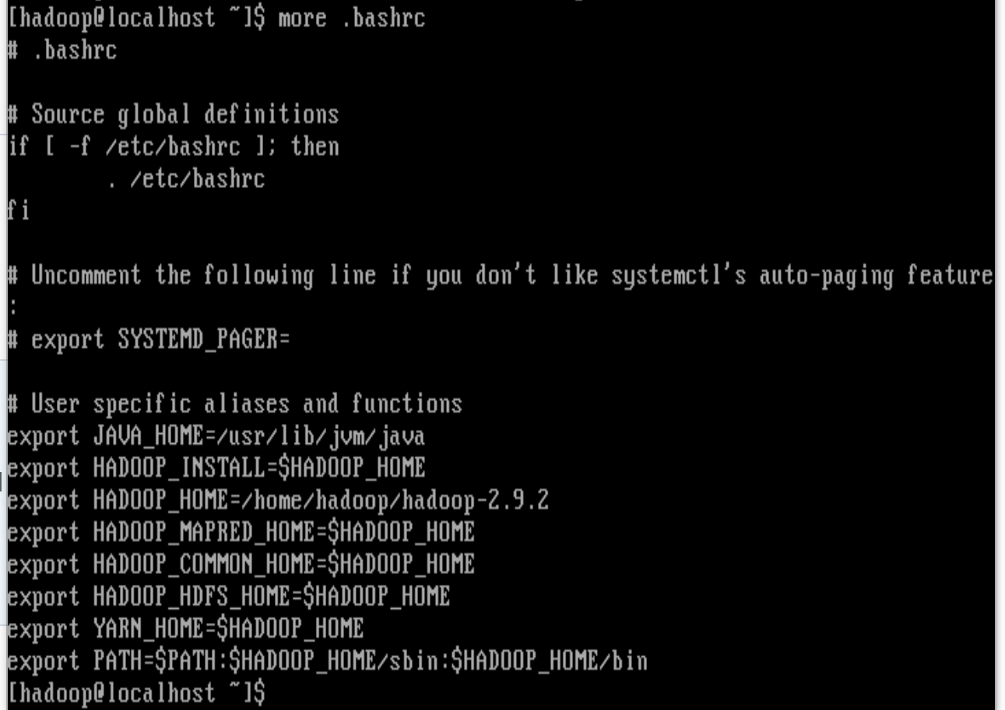

## 2.8 Enable and Verify Environment Variables

The export statements in the .bashrc file create environment variables for the login session.

These are enabled when you execute the command su command as shown below (they are also enabled when you log in as the user again).

Su – Hadoop

Remember the dash character in this command means change to the home directory for the Hadoop user and then “run” the .bashrc file contents.

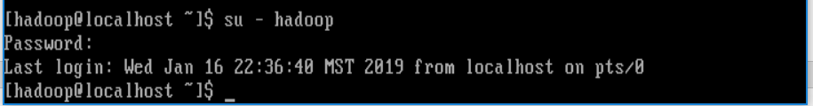

To verify the values for these environment variables, you can use the Linux command echo. Make sure to use capital letters for the variable names since Linux is case sensitive

Echo $JAVA_HOME

Echo $HADOOP_HOME

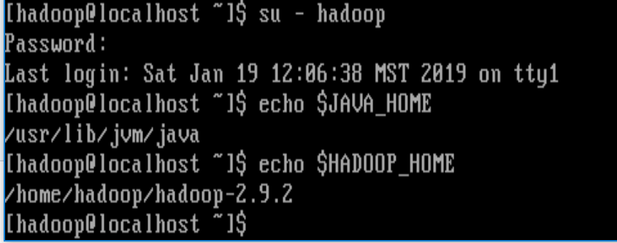

## 2.9 Configure Hadoop’s XML Files

Hadoop configuration are held in XML files located in the Hadoop distribution.

Using the cd command and our new environment variable to navigate to the Hadoop directory using: cd command and our new environment variable to navigate to the Hadoop directory using: cd $HADOOP_HOME

Then enter the pwd command to verify your location. Using the variables is a quick way to navigate.

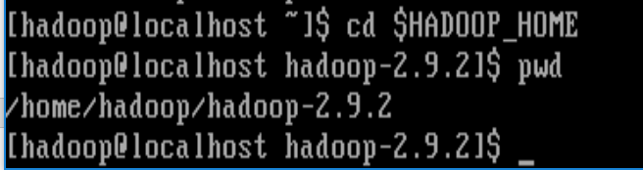

Enter the Linux ls command to check the contents of the directory. Then, change directories into the etc directory using cd etc

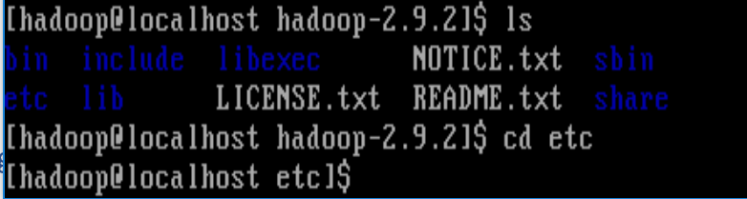

There is a subdirectory called Hadoop. Change into the Hadoop directory using cd Hadoop and then use the ls command

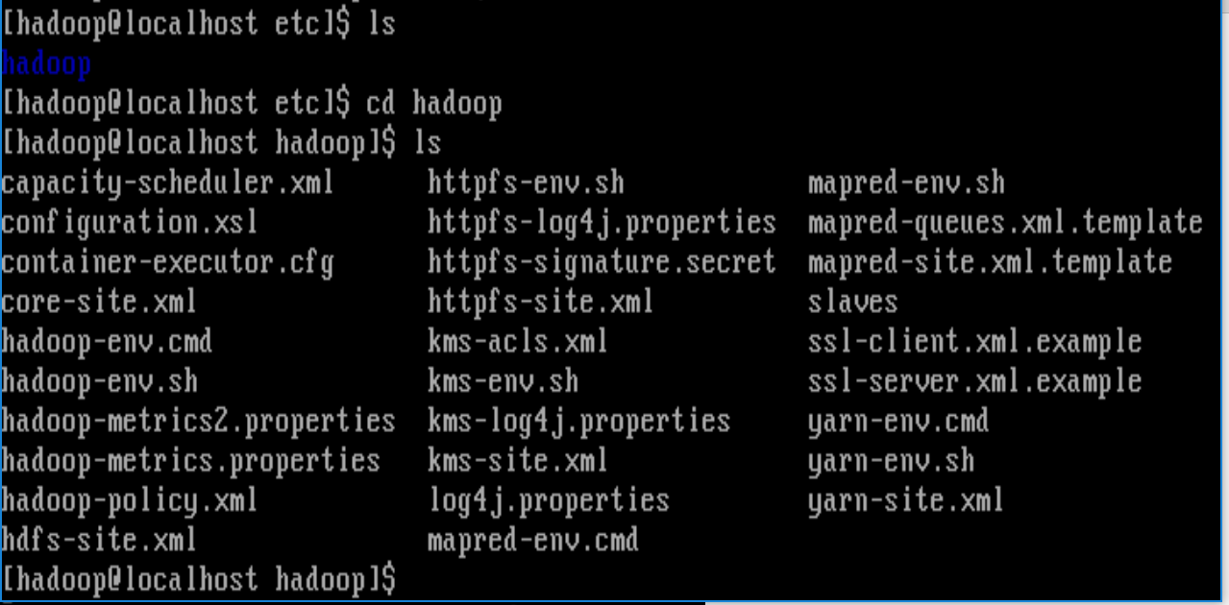

## 2.10 Configure core-site.xml

Use the nano editor to add these lines to the core-site.xml file under the first configuration tag <configuration>. XML is a tag based language based on html. Remember, capitalization matters.

Nano core-site.xml

<property>

<name>fs.defaultFS</name>

<value>hdfs://localhost:9000</value>

</property>

Your file should look like the one below:

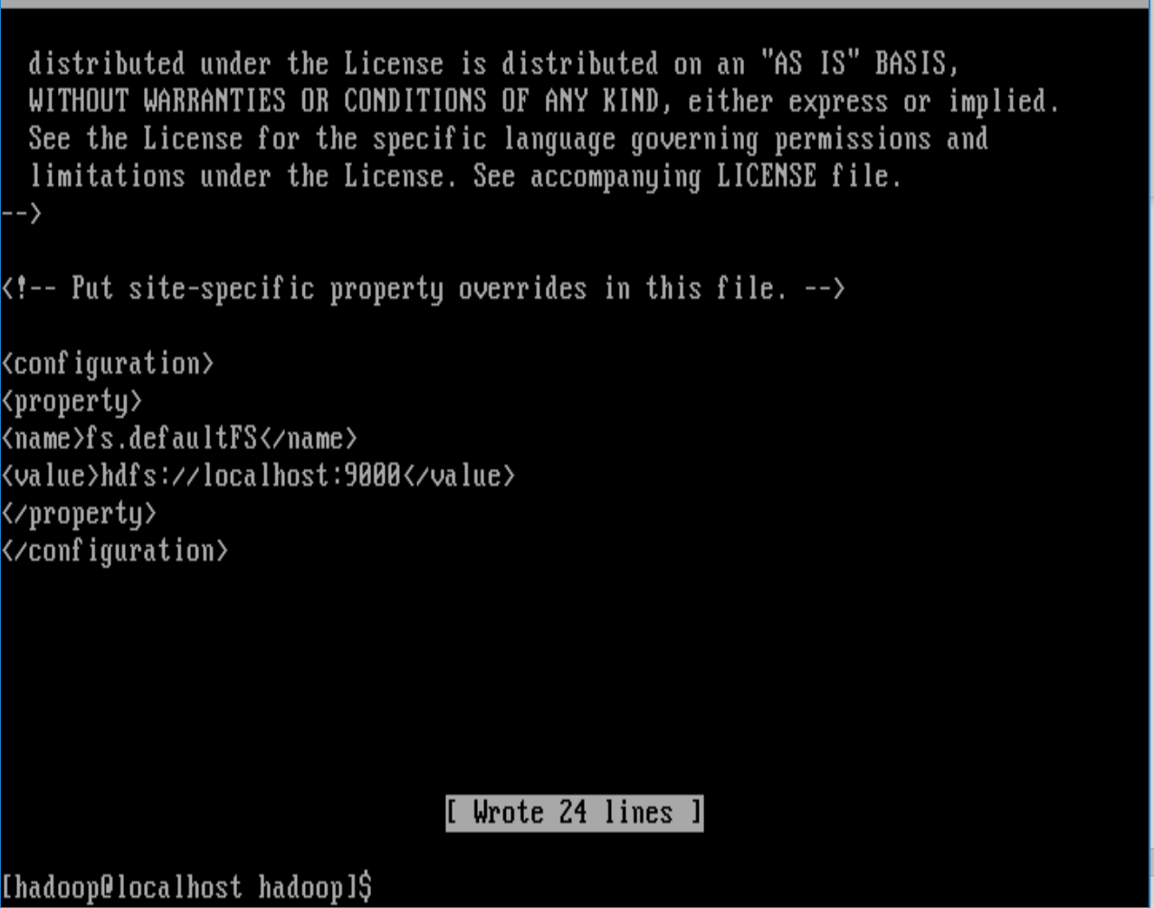

## 2.11 Configure hdfs-site.xml

Add the necessary lines to the hdfs-site.xml file under the first configuration tag <configuration>, so that you match the example below.

Remember to save the file and then exit

Nano hdfs-site.xml

<property>

<name>dfs.replication</name>

<value>1</value>

</property>

<property>

<name>dfs.name.dir</name>

<value>file:///home/hadoop/hadoopdata/hdfs/namenode</value>

</property>

<property>

<name>dfs.data.dir</name>

<value>file:///home/hadoop/hadoopdata/hdfs/datanode</value>

</property>

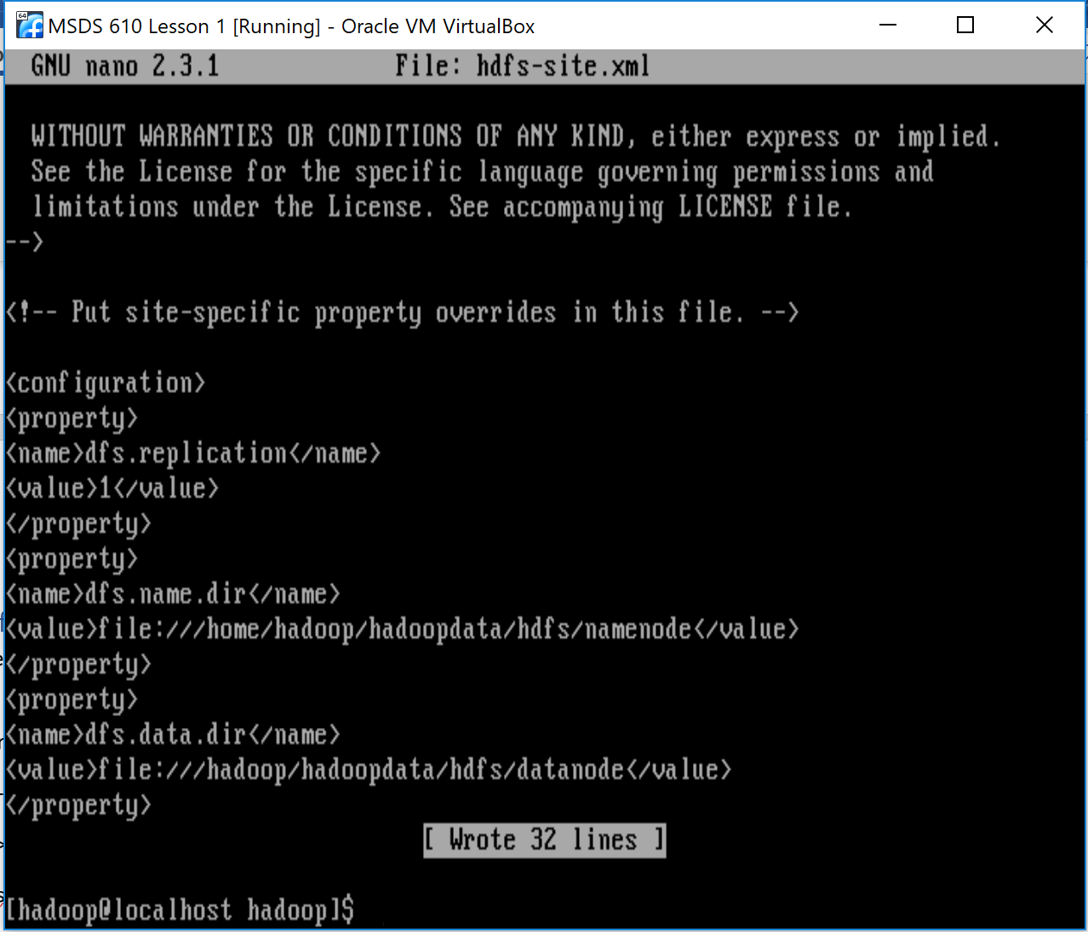

## 2.12 Configure mapred-site.xml

First copy the file mapred-site.xml.template to mapred-site.xml using the following cp command

Cp mapred-site.xml.template mapred-site.xml



Now, add the following lines under the first configuration tag <configuration>, so that you match the example below using nano mapred-site.xml. Commands:

nano mapred-site.xml

<property>

<name>mapreduce.framework.name</name>

<value>yarn</value>

</property>

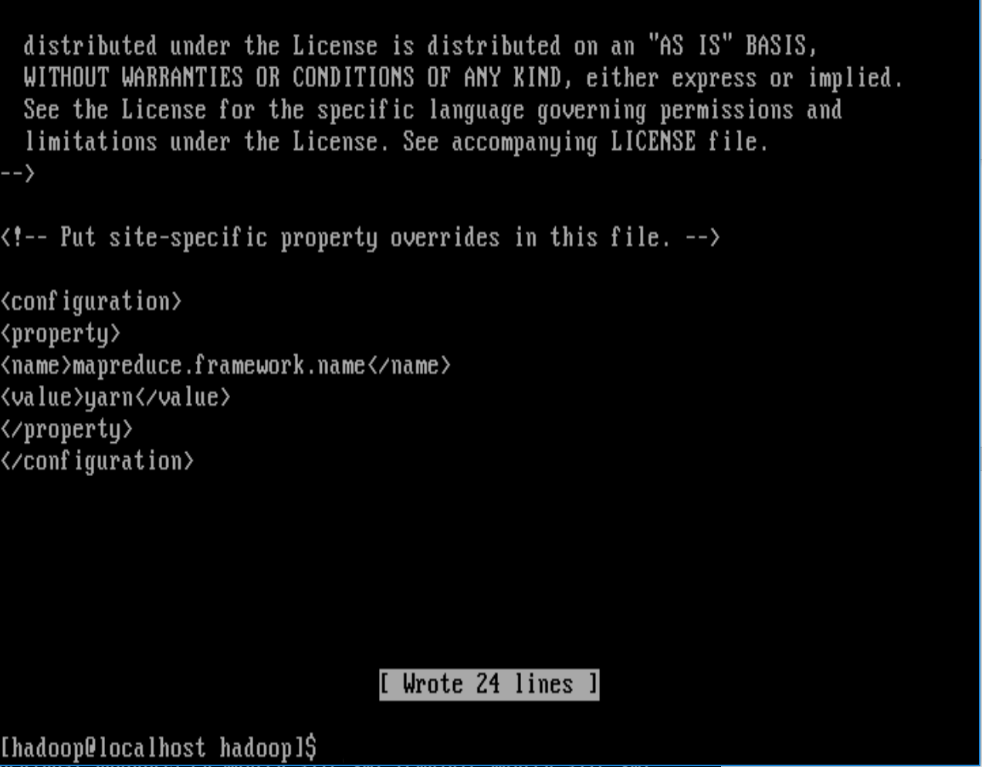

## 2.13 Configure yarn-site.xml

Configure the yarn-site.xml using nano yarn-site.xml. Remember to save and exit.

Nano yarn-site.xml

<property>

<name>yarn.nodemanager.aux-services</name>

<value>mapreduce_shuffle</value>

</property>

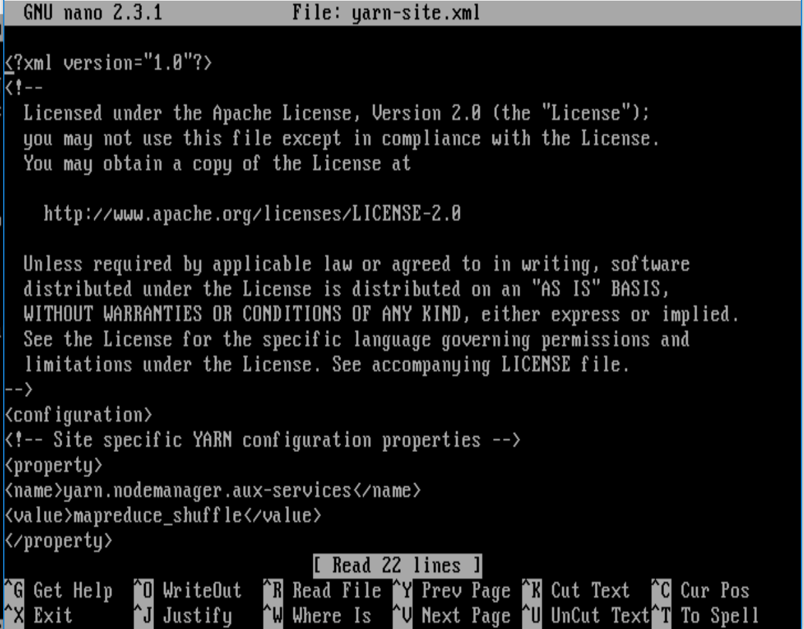

## 2.14 Format the Namenode

Return to the Hadoop home directory /home/Hadoop using the cd command.

Cd /home/Hadoop

Use the Linux command hdfs Namenode -format to format the Namenode

[hadoop@localhost hadoop]$ hdfs namenode -format

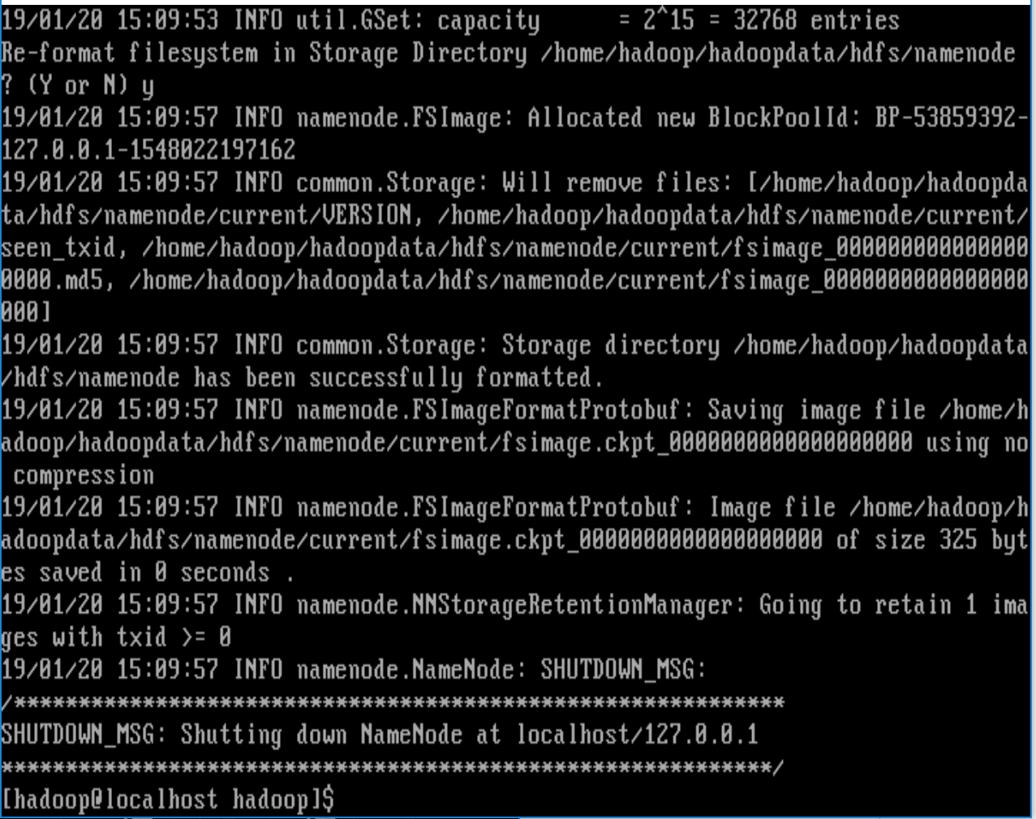

## 2.15 Start HDFS, YARN, and the Job History Server

Using the Hadoop shell scripts:

• start-dfs.sh

• start-yarn.sh

• mr-jobhistory-daemon.sh start historyserver

First start HDFS, then YARN, and then thi e Job History Server. Enter passwords for the hadoop user ID when prompted and answer yes to any prompts.

[hadoop@localhost ~]$ start-dfs.sh

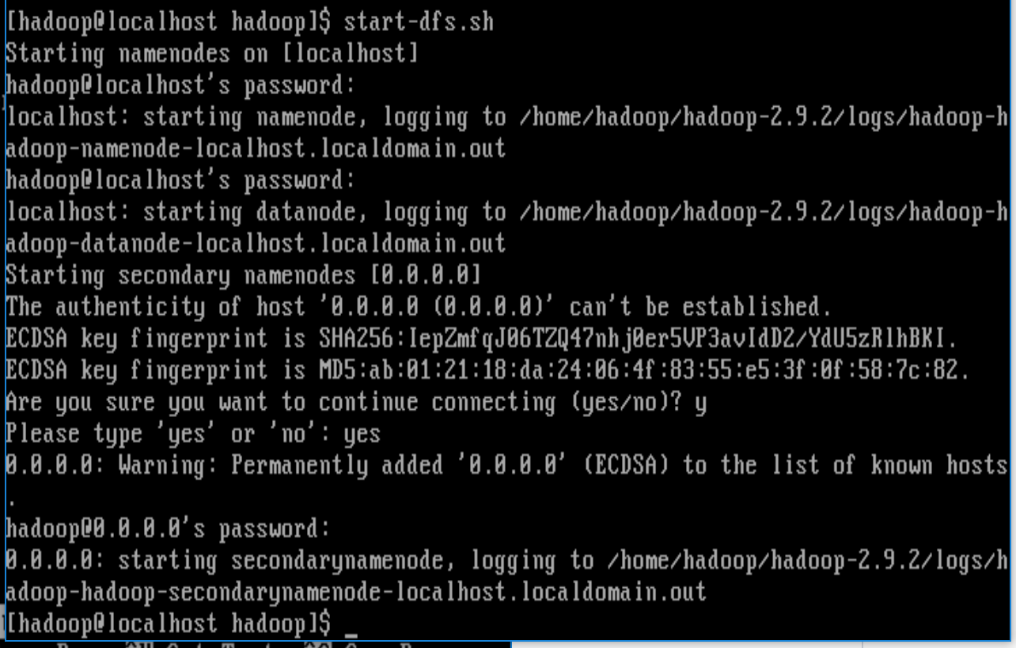

[hadoop@localhost~]$ start-yarn.sh

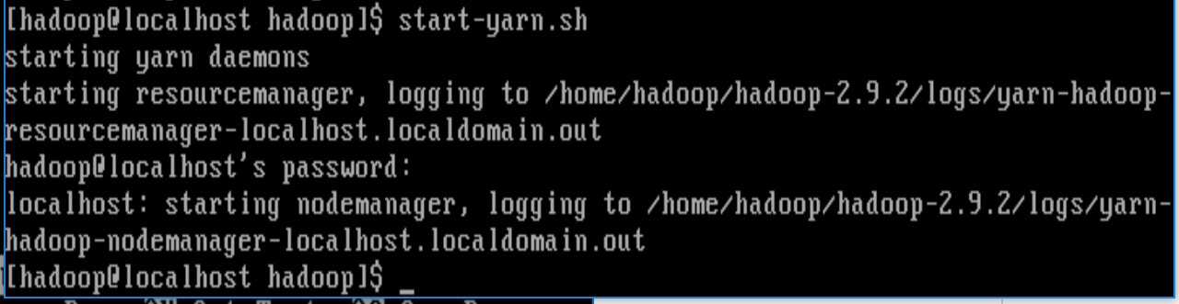

[hadoop@localhost~]$ mr-jobhistory-daemon.sh start historyserver

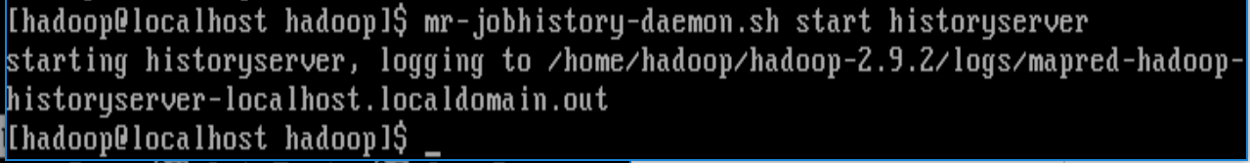

After starting these processes use the jps command to verify that they are all running. Start-dfs.sh starts the NameNode, DataNode, and the SecondaryNameNode processes. The start-yarn.sh starts the NodeManager and ResourceManager processes. Mr-jobhistory-daemon.sh is used to start the JobHistoryServer process.

[hadoop@localhost~]$ jps

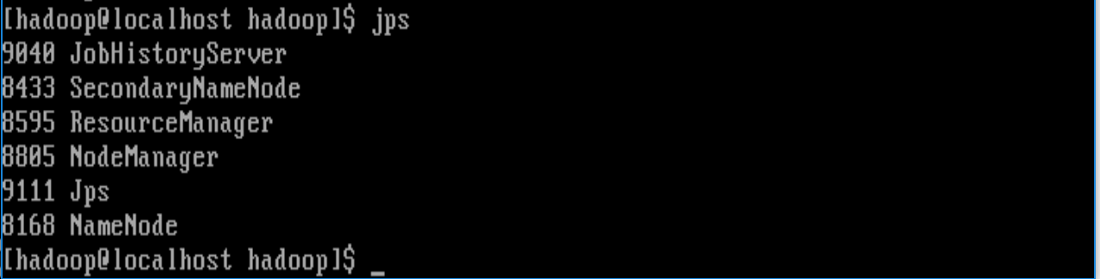

## 2.16 Run the Word Count Problem

The “Word Count” problem with Hadoop is the analog of the “HelloWorld” problem for computer programming. One of its uses is to demonstrate that you have a working Hadoop installation.

The text data that we will use for this test is the works of Shakespeare. Use the wget command to get the data from the internet.

Change to the main Hadoop directory using cd /home/Hadoop or the Hadoop home environment variable (your choice). Type a pwd to verify the directory and type a ls command to see the files in the directory as shown below. Then, run the wget to download the file from the internet.

wget http://norvig.com/ngrams/shakespeare.txt

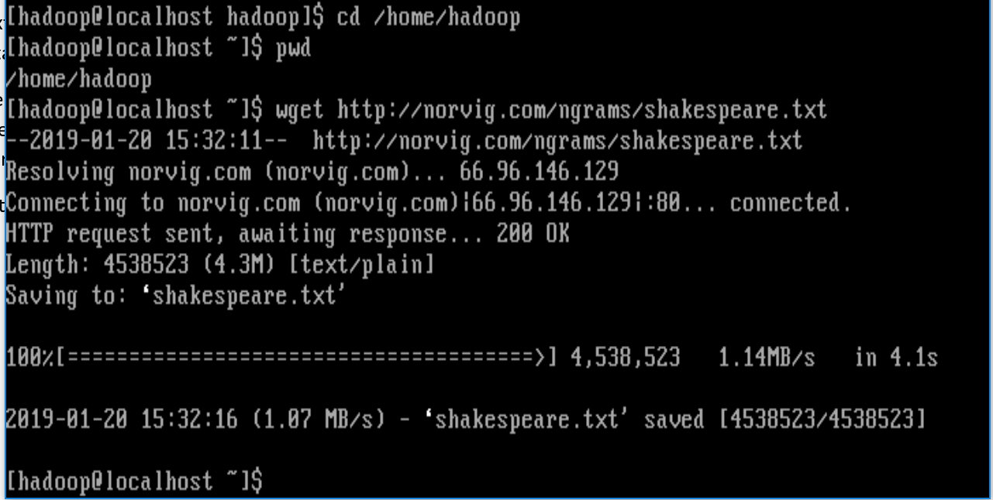

Now, create directories in HDFS for the data. This is done with the hadoop fs command.

1. The first command below creates a home directory, in HDFS, for the hadoop user.
2. The second command creates a directory, called shakespeare, in the home directory.
3. The third command creates a directory, called input, in the shakespeare directory.
4. The fourth command copies the data from the local file system to HDFS.
5. The fifth command lists the content of the HDFS directory /user/hadoop/shakespeare/input

[hadoop@localhost ~]$ hadoop fs -mkdir -p /user/hadoop

[hadoop@localhost ~]$ hadoop fs -mkdir shakespeare

[hadoop@localhost ~]$ hadoop fs -mkdir shakespeare/input

[hadoop@localhost ~]$ hadoop fs -copyFromLocal shakespeare.txt shakespeare/input

[hadoop@localhost ~]$ hadoop fs -ls shakespeare/input

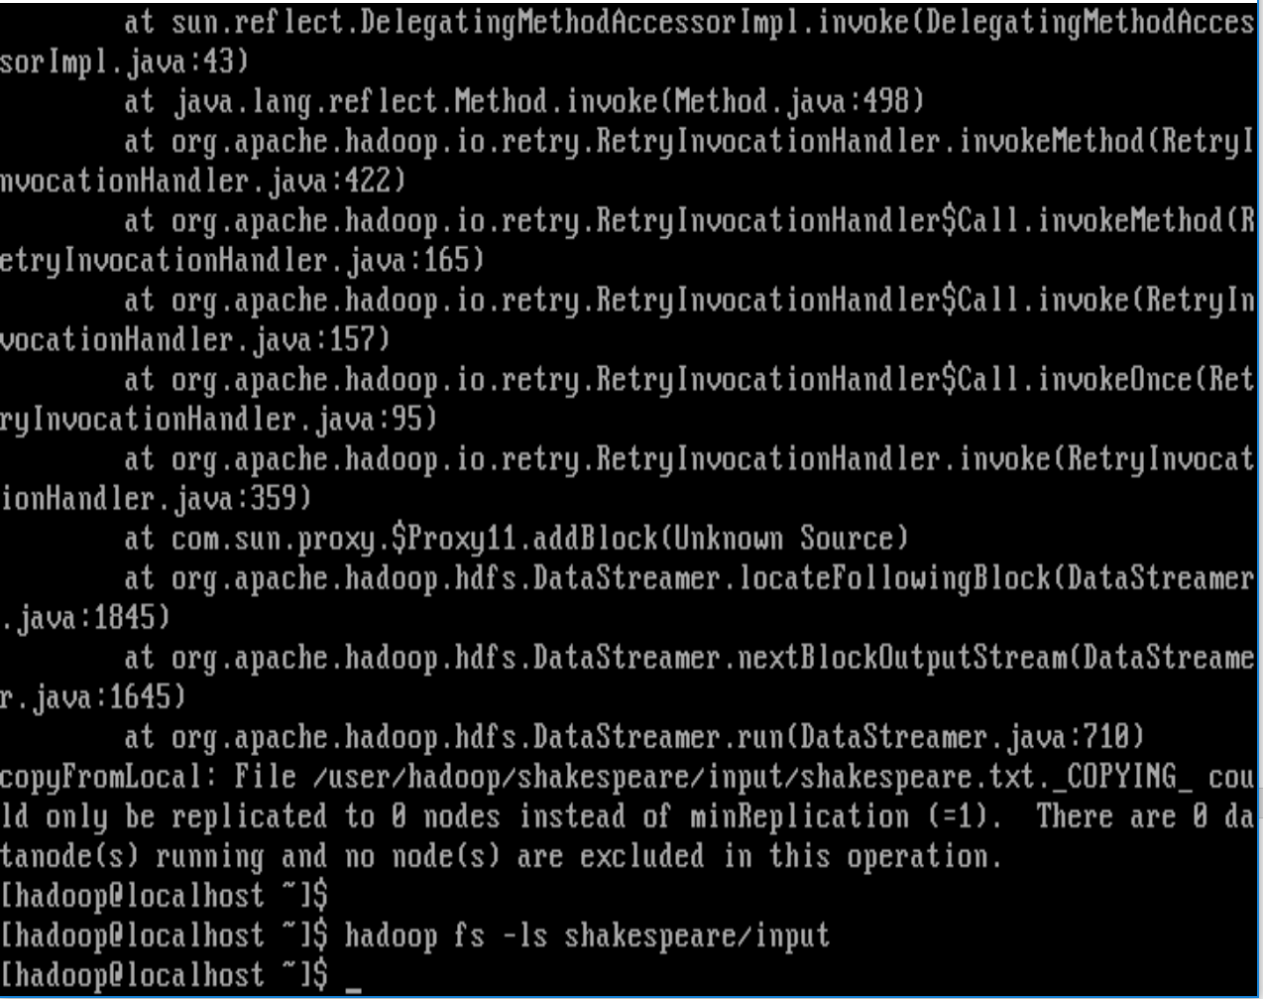

The input data has been loaded into HDFS and we are now ready to run the word problem on it.

The Hadoop distribution has this problem coded, in Java software, that is included in a jar file. This and other jar files are located in the share directory of the Hadoop distribution. Specifically, the fully qualified name of the jar file is:

/home/hadoop/Hadoop-2.9.2/share/hadoop/mapreduce/hadoop-mapreduce-examples-2.7.5.jar

To run the word count problem with the Shakespeare.txt file input and output to the HDFS directory shakespeare/output enter the command as follows:

Hadoop jar /home/Hadoop/Hadoop-2.9.2/share/Hadoop/mapreduce/Hadoop-mapreduce-examples-2.9.2.jar wordcount shakespeare/input shakespeare/output

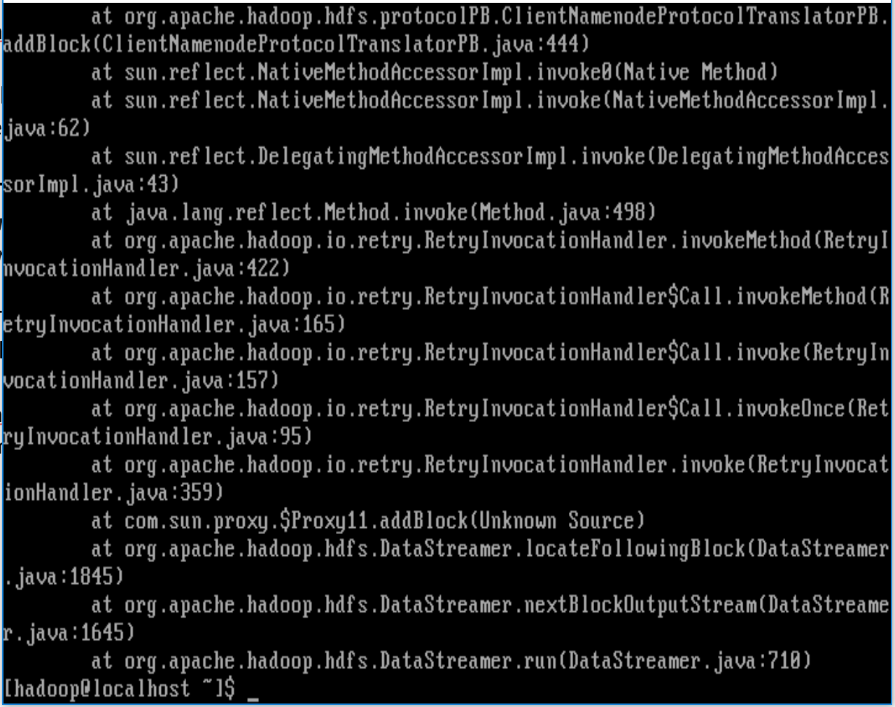

The output of the mapreduce wordcount problem was written to the shakespeare/output file. You can list the contents of the directory with the command: Hadoop fs -ls shakespeare/output



The contents of the output file can be seen with the command:

Hadoop fs -cat shakespeare/output/part-r-00000

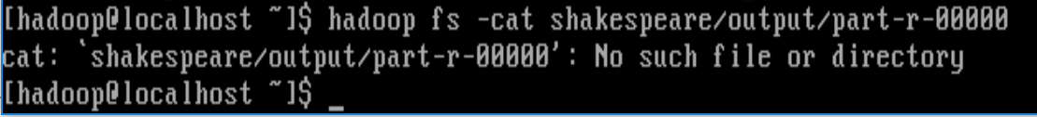

You should see a long list of words with the number of times they occur in the input data. You can copy the data from HDFS to the local file system with the command.

Hadoop fs -copyToLocal shakespeare/output/part-r-00000 ~/shakespeare.txt



The file shakespeareoutput.txt will be created in your home directory. Then use the more command to view the output page by page

[hadoop@localhost ~]$ more shakespeareoutput.txt

## 2.17 Stop HDFS, YARN, and the Job History Server

To stop these services, execut the commands below:

* Mr-jobhistory-daemon.sh stop historyserver
* stop-yarn.sh
* stop-dfs.sh

[hadoop@localhost ~]$ mr-jobhistory-daemon.sh stop historyserver

stopping historyserver

[hadoop@localhost ~]$ stop-yarn.sh

stopping yarn daemons

stopping resourcemanager

localhost: stopping nodemanager

no proxyserver to stop

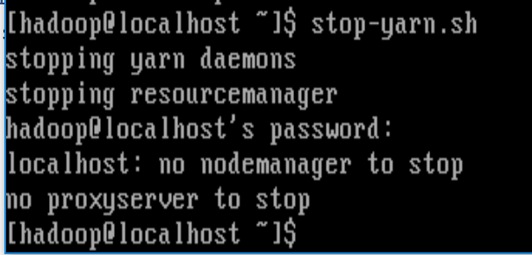

[hadoop@localhost ~]$ stop-dfs.sh

Stopping namenodes on [localhost]

localhost: stopping namenode

localhost: stopping datanode

Stopping secondary namenodes [0.0.0.0]

0.0.0.0: stopping secondarynamenod

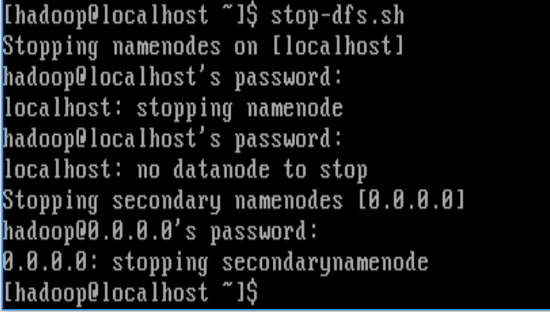

## Conclusions from Lab 1

After going through Lab 1 I learned a lot about how to load and set up Virtual Machines as well as the power of Hadoop and how to load big data files within it to run analysis. Though at the end I was not able to figure out the correct way to properly run the analysis on the Shakespeare text, I gained a lot of insight from closely following the steps in the Lab 1 Instructions to get the desired output and I know the knowledge I learned from Lab 1 will help me with labs later on in this class and other projects I take on throughout my career as a data scientist.